Stage 4 ★
Mixed Selection 1

- Pencil turning
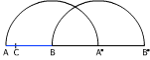
A pencil AB lying on a table is given a half turn about the end B (so that A moves to A*) and then a half turn about A* (so that B moves to B*). The point C on the pencil is one third of the way from A to B.
What is the ratio of the total distances moved by A and by C?

- 3-sided
Jack's teacher asked him to draw a triangle of area $7{\text{cm}}^{2}$. Two sides are to be of length $6\text{cm}$ and $8\text{cm}$. How many possibilities are there for the length of the third side of the triangle?

- Snail’s pace
A snail is at one corner of the top face of a cube with side length 1m. The snail can crawl at a speed of 1m per hour.
What proportion of the cube's surface is made up of points which the snail could reach within one hour?

- Triangular wheel
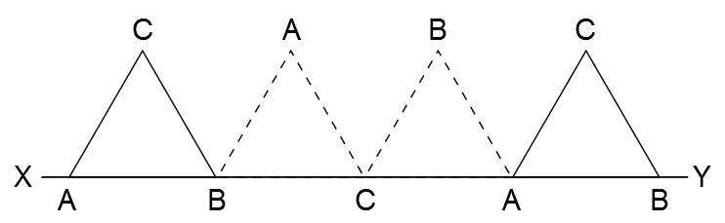
The equilateral triangle ABC has sides of length 1 unit and AB lies on the line XY. The triangle is rotated clockwise around B until BC lies on the line XY. It is then rotated similarly around C and then about A as shown in the diagram. What is the length of the path traced out by point C during this sequence of rotations?

