Stage 3
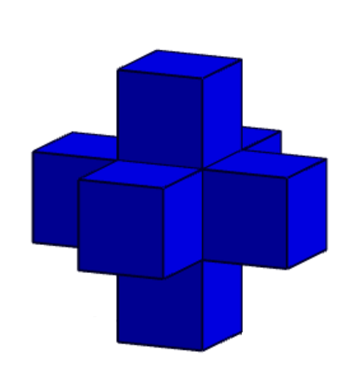
Mixed Selection 1
- Cubic covering
Take one blue unit cube and glue a further blue unit cube to each of its faces (to make a 3D cross).
If unit cubes coloured yellow are now glued face-to-face to all the spare faces of the blue cross, how many yellow unit cubes are required?
- Red or black
Each edge of a cube is coloured either red or black. If every face of the cube has at least one black edge, what is the smallest possible number of black edges?

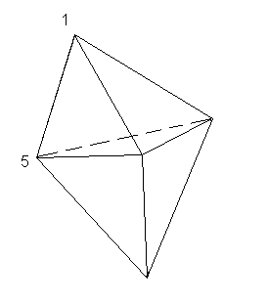
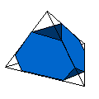
- Truncated tetrahedron
A regular tetrahedron with edges of length 6 cm has each corner cut off to produce the solid shown. The triangular faces are all equilateral triangles, but not necessarily the same size.
What is the total length of the edges of the resulting solid?
- Facial sums
The diagram shows a solid with six triangular faces. At each vertex there is a number and two of the numbers are 1 and 5, as shown. The sum of the numbers at the three vertices of each face is calculated, and all the sums are the same.
What is the sum of all five numbers at the vertices?
- Pyramidal n-gon
The base of a pyramid has n edges. In terms of n, what is the difference between the number of edges of the pyramid and the number of faces?

