Stage 3
Mixed Selection 2
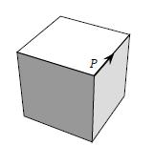
- Crawl around the cube
An ant crawls carefully around the edges of a cube, starting at point P and in the direction of the arrow.
At the end of the first edge, it chooses to go either left or right. It then turns the other way at the end of the next edge and continues like this, turning right or left alternately at the end of each successive edge.
After how many edges does the ant return to point P for the first time?
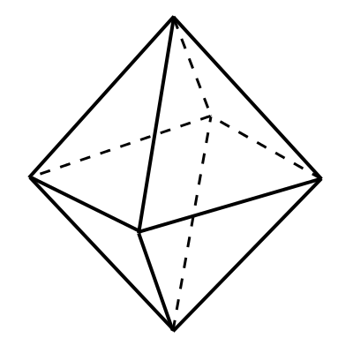
- Painted octahedron
The faces of a regular octahedron are to be painted so that no two faces which have an edge in common are painted in the same colour.

What is the smallest number of colours required?
- Daniel’s Star
Daniel creates a solid 'star' shape by gluing square-based pyramids onto each face of a cube, so that the cube is completely hidden.
How many faces does his 'star' have?
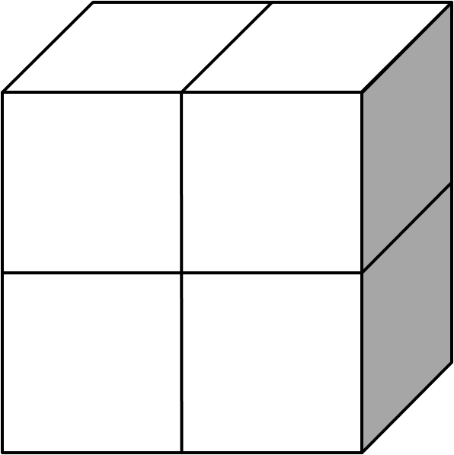
- Four cubes
Four cubes, each with a surface area of $24{cm}^{2}$ are placed together to make a cuboid as shown.
What is the surface area of this cuboid, in ${cm}^{2}$?
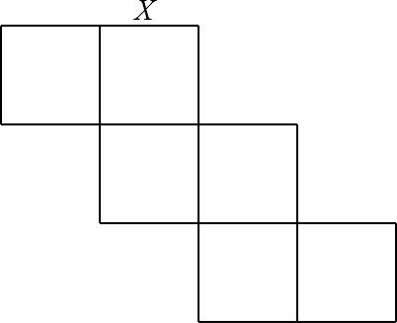
- Net profit
The diagram shows the net of a cube.
Which edge meets the edge X when the net is folded to form the cube?

