Stage 3
Mixed Selection 1
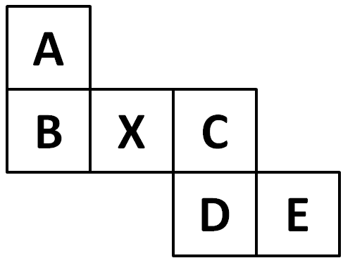
- Net result
The net shown here is cut out and folded to form a cube.
Which face is then opposite the face marked X?

- Cubic vision
A wooden cube measuring 11cm by 11cm by 11cm is made from centimetre cubes.
What is the greatest number of centimetre cubes visible from any point?
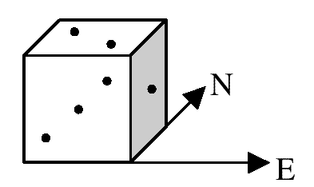
- Dicey directions
The diagram shows an ordinary die in which the scores on opposite faces always total 7.
It is placed on a horizontal table with the '1' face facing East. The die is moved four times, rotating it each time through 90° about an edge. The faces in contact with the table are first 1, then 2, then 3, then 5.
In which direction is the '1' facing after this sequence of moves?
- Painted purple
A wooden cube has three of its faces painted red and the other three of its faces painted blue, so that opposite faces have different colours. It is then cut into 27 identical smaller cubes.
How many of these new cubes have at least one face of each colour?
- Sugary diversion
An ant is crawling in a straight line from one corner of a table to the opposite corner when he bumps into a one centimetre cube of sugar. Instead of crawling round it, or eating his way through it, he climbs straight up and over it before continuing on his intended route.
How much does the detour add to the length of his journey?

