Stage 3
Mixed Selection 1 - Solutions

- Cubic covering
We glue the yellow faces to the up and bottom faces of the blue cross. We require 5 yellow cubes for wrapping each of the two blue cubes. (We used transparent yellow cubes)
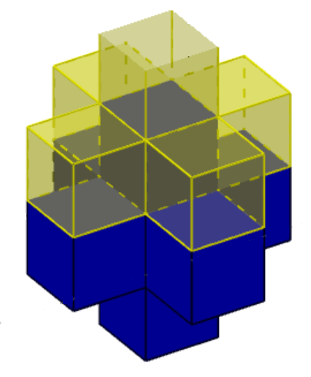 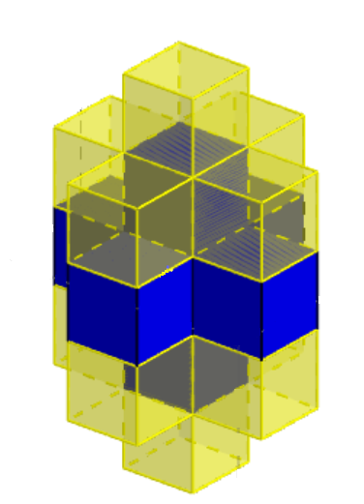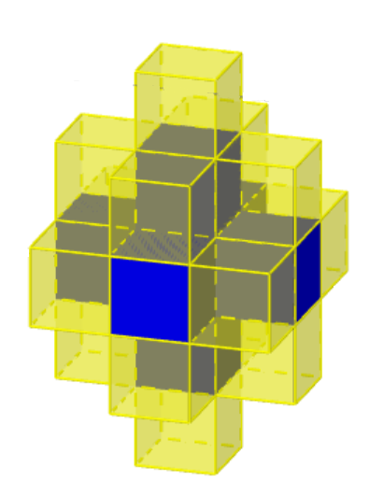
Now we need one yellow cube for each of the four corners
Finally, we have 4 faces to cover, so we need 4 more cubes.
Therefore, we used 5+5+4+4=18 yellow cubes.
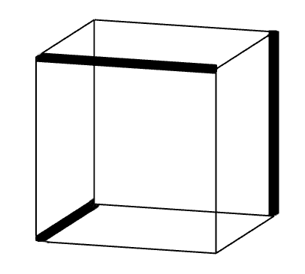
- Red or black
Each edge of the cube borders two faces. As there are six faces, a minimum of three black edges will be required.
The diagram shows that three black edges is enough.
- Truncated tetrahedron
At each vertex, the piece that has been removed is a regular tetrahedron. Three of the edges of this are the pieces of edge that are lost from the original tetrahedron, the other three are the new edges of the truncated tetrahedron. Since all the edges are the same length, this means the total length of the edges remains unchanged.
Therefore, the total length of the edges is 6cm×6=36cm.

- Facial sums
Let the numbers at two of the other vertices be u and v. The three faces sharing the vertex labelled with the number 1 all have the same sum. Then 1+v+u=1+5+u and so v=5.
Similarly, 1+v+5=1+v+u so u=5.
Hence the sum for each faces is 1+5+5=11, and we see that the number at the bottom vertex is 1.
The total of all the vertices is 1+5+5+5+1=17.

- Pyramidal n-gon
The base consists of 1 face and n edges. At each of the n vertices of the base, there is a unique edge which passes through the peak of the pyramid. Each edge corresponds to a unique face (say, the one on its left). This gives n+1 faces and 2n faces – giving a difference of: $2n-(n+1)=n-1$

