Stage 3
Mixed Selection 2 - Solutions

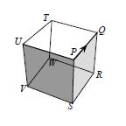
- Crawl around the cube
At Q the ant can choose first to go left to T, then right to W. Otherwise, at Q it can go right to R and then left to W.
W is the corner diagonally opposite to P and is reached by either route after three edges (and no fewer). So after exactly three more edges, the ant must reach the corner opposite W, that is, P.
- Painted octahedron
Two colours is enough: pick any triangle, and colour it red or blue (say, red). Then its three neighbouring faces must be blue. For each of the blue faces, each of its neighbours has neighbours which are either empty or blue – so we may paint them all red. These new red faces all share one empty neighbour, which we may colour blue.
- Daniel’s star
Each pyramid has five faces, but the square base is glued onto the cube, and so is not a face of the star. There are 6 pyramids, each contributing 4 faces, so the star has 24 faces.
There is one height of pyramid which will make the two faces that meet at each of the original edges become one face, giving a solid with 12 rhomboidal faces.
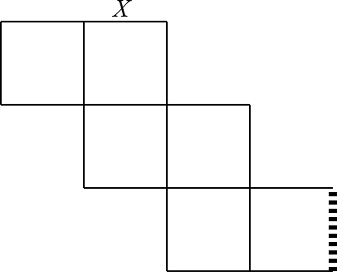
- Four cubes
Each cube has 6 identical faces, which have area $24÷6=4{cm}^{2}$
The cuboid has 16 of these same square faces, and thus has area $16×4{cm}^{2}=64{cm}^{2}$
- Net profit
The dashed edge in the diagram meets X when the net is folded into a cube.

