Stage 4 ★★★
Mixed Selection 1

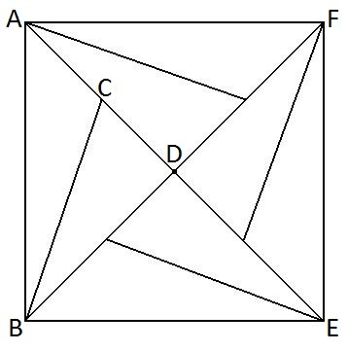
- Symmetric angles
The diagram has rotational symmetry of order 4 about $D$.

If angle $ABC$is 15$°$ and the area of $ABEF$ is 24$\text{c}{\text{m}}^{\text{2}}$, what is the length of $CD$?

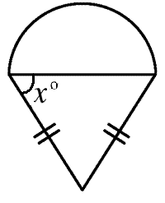
- Ice cream tangent
The diagram shows a semi-circle and an isosceles triangle which have equal areas.
What is the value of $\tan{x}$?

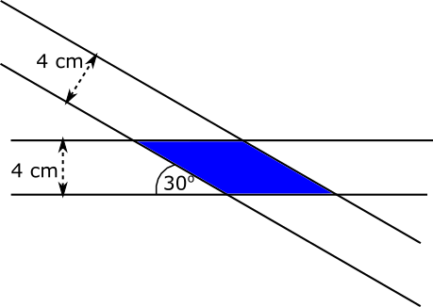
- Overlapping ribbons
Two strips of ribbon, each of width 4 cm, are laid across each other at an angle of ${30}^{o}$, as shown in the diagram.
Find the exact area of the overlap.

- The roller and the triangle
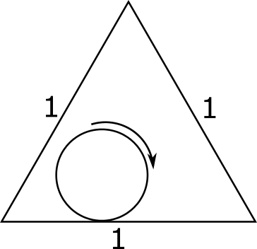
Clare is painting the inside of a short triangular prism with a roller.
The cross-section of the prism is an equilateral triangle with side length 1, and the cross-section of the roller is a circle with circumference 1. This is shown in the diagram.
What is the total length that Clare can paint?
Give an exact answer.

