Stage 4
Mixed Selection 1
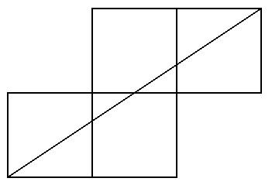
- Tetromino diagonal
Four unit squares are placed edge to edge as shown. What is the length of the diagonal line drawn?
- Out of the window
I have four rectangular pieces of thin hardboard whose dimensions (in cm) are 55 x 85, 65 x 75, 65 x 85, 90 x 105.
Without bending the hardboard, how many of these can I get through an open rectangular window measuring 60 cm x 80 cm?
- Folding in half
The shorter sides of a right-angled isosceles triangle are each 10cm long. The triangle is folded in half along its line of symmetry to form a smaller triangle. How much longer is the perimeter of the larger triangle than that of the smaller?
- Right-angled possibilities
If two of the sides of a right-angled triangle are 5cm and 6cm long, how many possibilities are there for the length of the third side?
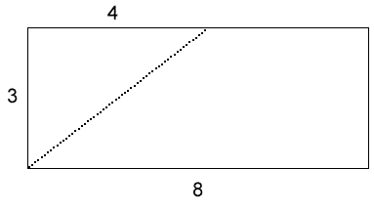
- Rectangle Rearrangement
A 3×8 rectangle is cut into two pieces along the dotted line shown. The two pieces are then rearranged to form a right-angled triangle. What is the perimeter of the triangle formed?

