Stage 4
Mixed Selection 1 – Solutions

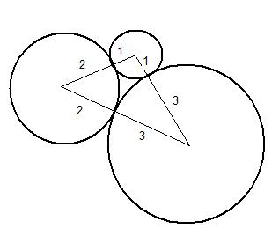
- Circle time
The triangle that joins up the centres of the circles has sides of length 3 cm, 4 cm, 5 cm. Since there is a right-angled triangle with sides 3, 4, 5, and since if two triangles share the lengths of their sides they are congruent, this angle must be right-angled. Therefore the length of the longer arc of the circle ${\text{C}}_{\text{1}}$ is $\frac{\text{3}}{\text{4}}\text{×}\text{2}\text{π}\text{×}\text{1}\text{=}\text{32}\text{π} \text{cm}$.
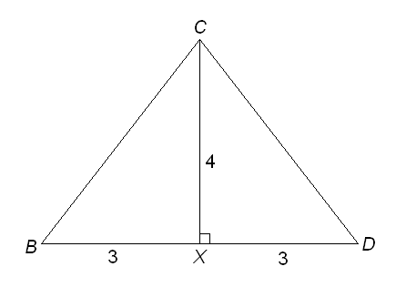
- Unusual Polygon
The area of square BDFG is 6×6=36 square units.
So the total area of the three triangles ABG, BCD and DEF is also 36 square units. Since these triangles are congruent, each has an area of 12 square units.
The area of each triangle is $\frac{1}{2}×\text{base}×\text{height}\text{, }$and the base is 6 units and hence we have $\frac{1}{2}×6×\text{height}=12$, so the height is 4 units.
Let X be the midpoint of BD. Then CX is perpendicular to the base BD (since BCD is an isosceles triangle).
By Pythagoras' Theorem, $BC=\sqrt{3^{2}+4^{2}}=5$
Therefore the perimeter of ABCDEFG is
$$6×5+6=36$$

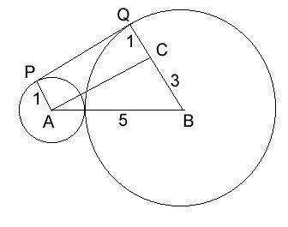
- Common tangent
The diagram shows points A and B, the centres of the two circles, and C, on line BQ such that AC is parallel to PQ. Since ACQP is a rectangle, ACB is a right angled triangle. So By Pythagoras' Theorem, AC=4, which is also the length of PQ.
- Triangular teaser
The diagram below shows isosceles triangles T and U. The perpendicular from the top vertex to the base divides an isosceles triangle into two congruent right-angled triangles as shown in both T and U. Evidently, by Pythagoras' Theorem, h=4 and k=3. So both triangles T and U consist of two 3, 4, 5 triangles and therefore have equal areas.
