Stage 4 ★★★
Mixed Selection 1 - Solutions

- Griddy region
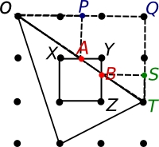
We want to find out how far the points $A$ and $B$ (the points on both the triangle and square) are from $Y$. The triangle $OQT$ is 3 units across by 2 units down. The triangle $OPA$ is similar to $OQT$, and is half its size (since it is one unit down rather than two). So the point $A$ is 3/2 units from $O$, so 3/2 - 1 = 1/2 units from $X$, so 1 – 1/2 = 1/2 unit from $Y$.
Similarly, the triangle $BST$ is 1/3 the size of $OQT$, so the point $B$ is 2/3 units from $Z$, so 1 - 2/3 = 1/3 unit from $Y$. So the triangle $AYB$ has area 1/2 x 1/2 x 1/3 = 1/12 square units, and the area of overlap is 1 – 1/2 = 11/12 square units.

- Two equilateral triangles
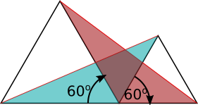
Consider the coloured triangles in the diagram below. They both have one side equal in length to the larger equilateral triangle, and these sides are at an angle of 60$°$ to each other. They also both have one side equal in length to the smaller equilateral triangle, and these sides are also at an angle of 60$°$ to each other.
So a 60$°$ rotation will map the blue triangle onto the red triangle. So the two triangles must be congruent. So the third sides, which are the red lengths, must be equal.

A fuller solution is available at: https://nrich.maths.org/12950/solution

- Cut-up square
First, we label the corners of the square, the midpoint, and the point at which the two lines intersect $A, B, C, D, E$ and $F$ respectively. We also label the four triangles created within the square as 1, 2, 3 and 4.
Call the area of triangle a.
Angle $AFD$ is equal to angle $EFC$ as they are vertically opposite, and angle $FAD$ is equal to angle $FCD$ as they are alternate. So, triangles 1 and 3 are similar. As $E$ marks the midpoint of a side of the square, length $CE$ is half the value of length $AD$.
This means that the area of triangle 3 is equal to 4a, as its base and height are double that of triangle 1.
It also means that length $AF$ is equal to twice the value of length $FC$. If we let $AF$ be the base of triangle 3 and $FC$ be the base of triangle 2, then these triangles have the same height (equal to the perpendicular distance from $D$ to the line $AF$) so the area of triangle 2 is equal to half that of triangle 3 - that is, 2a.
As line $AC$ is a diagonal, the combined areas of triangles 2 and 3 is equal to half the area of the square. 4a + 2a = 6a, so the square has a total area of 12a. The combined area of triangle 1 and triangle 4 is then also 6a. As we have defined the area of triangle 1 as a, we then know that triangle 4 has an area of 5a.
As the ratio of $P:Q$ is simply the ratio area of triangle 2:area of triangle 4, we then know that this ratio is 2a:5a=2:5.

- Garden fence
In the diagram below, triangle $ABC$ represents the garden, $CD$ represents the fence and$E$ is the foot of the perpendicular from $D$ to $AC$.
The two sections of the garden have the same perimeter so $AD$ is $10\text{m}$ longer than $DB$. Hence, $AD = 30\text{m}$ and $DB = 20\text{m}$.
Triangles $AED$ and $ACB$ are similar, so $\frac{AE}{AC}= \frac{AD}{AB}= \frac{30}{50}$ . Hence, $AE = \frac{3}{5} ×30\text{m}=18\text{m}$.
Also, $\frac{ED}{CB}= \frac{AD}{AB}= \frac{30}{50}$. Hence, $ED= \frac{3}{5} ×40\text{m}=12\text{m}$.
Finally, by Pythagoras: ${CD}^{2}= {EC}^{2}+ {ED}^{2}= \left({12}^{2}+ {24}^{2}\right){\text{m}}^{2}=5×{12}^{2}{\text{m}}^{2}$. So the length of the fence is $12\sqrt{5}\text{m}$.

- Folded square
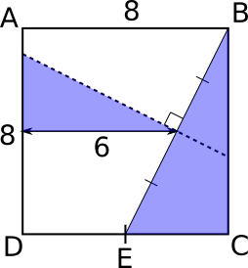
In the diagram below, the line EB has been added. The dotted line must be the perpendicular bisector of EB, since for B to fold onto E, B and E must be the same distance on either side of the fold.

The two triangles coloured blue are similar, as they both contain a right angle and their other two angles are 90$°$ rotations of each other.
The dotted line and the folded line cross halfway between E and B (since EB is bisected), so 4 cm from the top (and from the bottom) and 2 cm from the right (and from E). So the distance marked on the diagram below is 6 cm.
The sides of the larger triangle are in the ratio 1:2 (from 4:8), so the vertical side of the smaller triangle must be 3 cm. So the dotted line meets AD 4−3 = 1 cm below A.

A fuller solution is available at: https://nrich.maths.org/12983/solution

