Stage 4 ★★
Mixed Selection 2

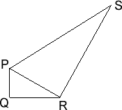
- Two right angles
In the figure above, $PQ=2\frac{1}{3}$, $PS=6\frac{6}{7}$, $PQR$ and $PRS$ are right-angled triangles, and the angles $QPR$ and $RPS$ are the same.
How long is $PR$?

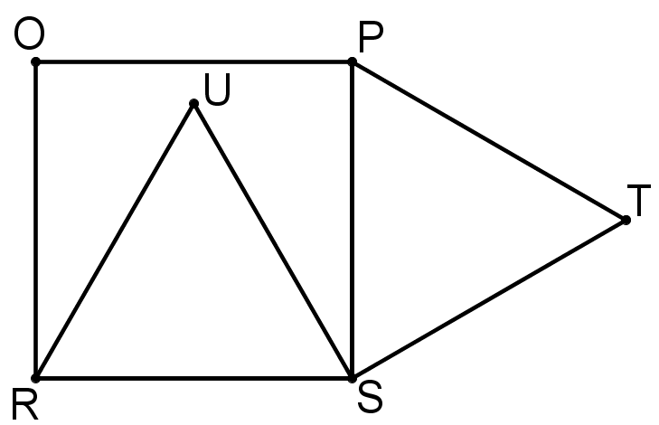
- Internal – external
The diagram shows a square $PQRS$ and two equilateral triangles $RSU$ and $PST$. $PQ$ has length 1.
What is the length of $TU$?

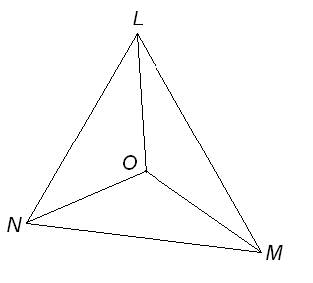
- Incentre angle
The three angle bisectors of triangle $LMN$ meet at a point $O$ as shown. We also know $∠LNM$ is 68$°$.

What is the size of $∠LOM$?
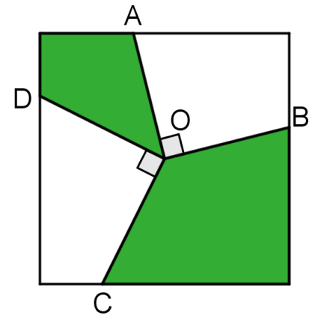
- Shaded square
The diagram on the right shows a square with side length $2\text{m}$ and lines drawn to its sides from its centre $O$. The points $A, B, C$ and $D$ are all on different sides of the square.
The lines $OA$ and $OB$ are perpendicular, as are $OC$ and $OD$.
What is the shaded area?

