Age 14+ Level
- Coloured Black
A square ink stamp has sides of length 1cm.
It is covered in black ink and carefully placed in the middle of a piece of white paper.
The stamp is then rotated $180°$ about one of its corners so that all of the square remains in contact with the paper throughout the turn, leaving a black trail.
The stamp is then removed from the paper.
What area of paper, in cm², is coloured black?

- Half Area
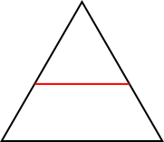
This equilateral triangle has sides of length 2 cm.

The red line, which is parallel to the base, divides this equilateral triangle into two shapes of equal area.

How long is the red line?

