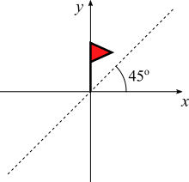
Age 11+ Level
- Flagged Up
The flag is given a half-turn anticlockwise about the origin and is then reflected in the dotted line.

What is the final position of the flag?

- Grid Symmetry
Mathias is given a grid of twelve small squares.
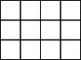
He is asked to shade exactly 4 of the squares so that the grid has 2 lines of reflection symmetry.

How many different grids could he produce?

