Age 14+ Level
Worksheet 1
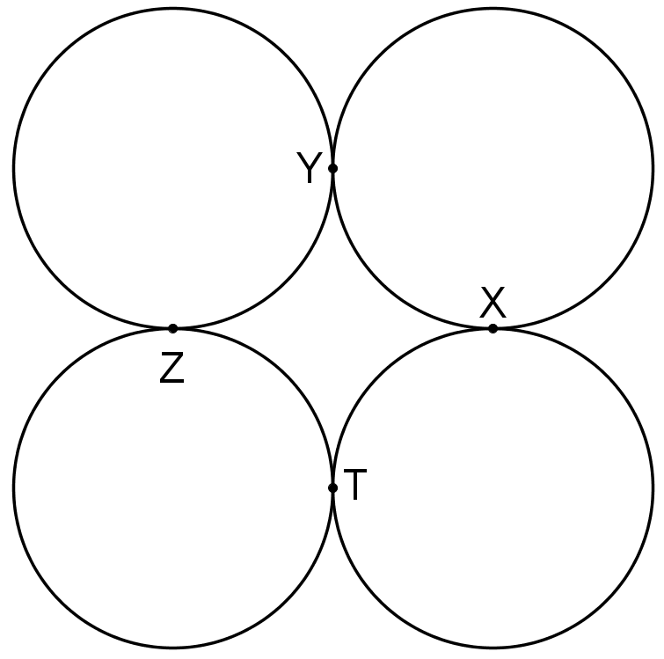
- Contact Circles
Four touching circles all have radius 1 and their centres are at the corners of a square.

What is the radius of the circle through the points of contact X, Y, Z and T?

