Age 11+ Level
Worksheet 1

- Folded A4
A sheet of A4 size paper (297mm x 210mm) is folded once and then laid flat on the table.

Which of these shapes could not be made?
a) 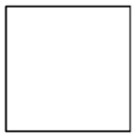 b) 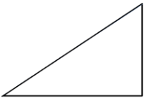 c) 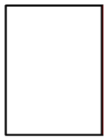 d) 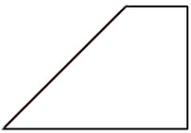 e) 