Stage 4 ★★★
Mixed Selection 1

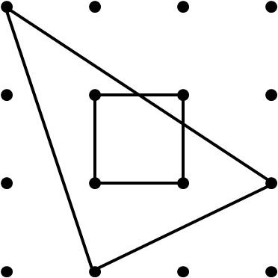
- Griddy region
The dots are one unit apart.
What is the area of the region common to both the triangle and the square (in square units)?

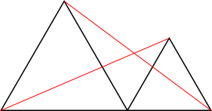
- Two equilateral triangles
The two black triangles are both equilateral, and their bases form a straight line segment.
Prove that the two red lines are of equal length.

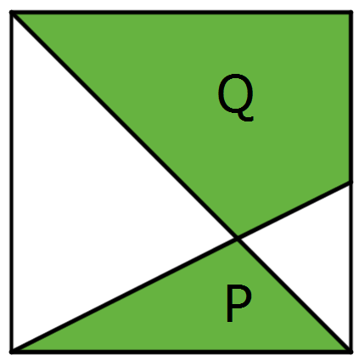
- Cut-up square
The diagram shows a square, a diagonal and a line joining a vertex to the midpoint of a side.
What is the ratio of area P to area Q?

- Garden fence
A garden has the shape of a right-angled triangle with sides of length 30, 40 and 50. A straight fence goes from the corner with the right-angle to a point on the opposite side, dividing the garden into two sections which have the same perimeter.
How long is the fence?

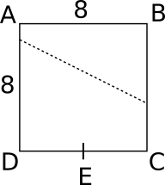
- Folded square
This 8 cm by 8 cm square of paper has been folded so that the corner at B lies exactly on top of E, the midpoint of CD. The dotted line shows the crease left by this fold.
How far from A does the dotted line reach the side AB?

