Stage 4 ★★
Mixed Selection 2 – Solutions

- Two right angles
Triangles $QPR$ and RPS are similar. So: $\frac{PR}{PS}=\frac{PQ}{PR}$. Hence $PR^{2}=PQ×PS=\frac{7}{3}×\frac{48}{7}=16$. So PR is 4 units long.

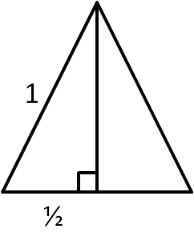
- Internal – external
$∠PSR=90°,$ as it is in a square.
$∠USR=∠TSP=60°,$ as they are in equilateral triangles.
Then, $∠PSU=90°-60°=30°$.
$∠TSU=60°+30°=90°$.
Thus, $TSU$ is a right angled triangle, so using Pythagoras' theorem: $UT=\sqrt{1^{2}+1^{2}}=\sqrt{2}$.

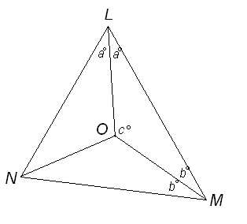
- Incentre angle
Let $∠OLM=∠OLN=a°, ∠OML=∠OMN=b°$ and $∠LOM=c°.$
Angles in a triangle add up to $180°$, so from $ΔLMN, 2a°+2b°+68°=180°$, which gives $2(a°+b°)=112°$. In other words $a°+b°=56°.$
Also, from $ΔLOM, a°+b°+c°=180°$, and so $c°=180°-(a°+b°)=180°-56°=124°$.
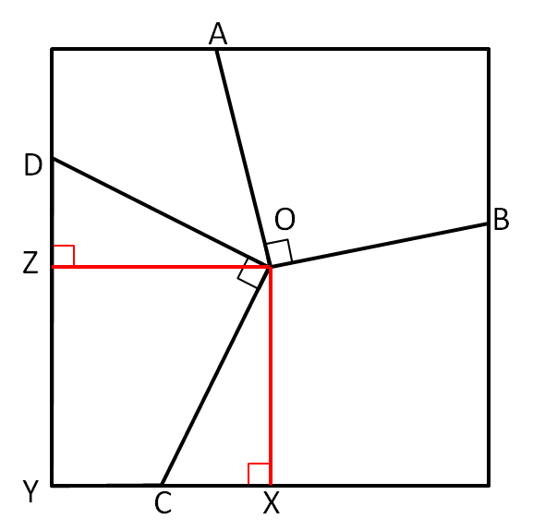
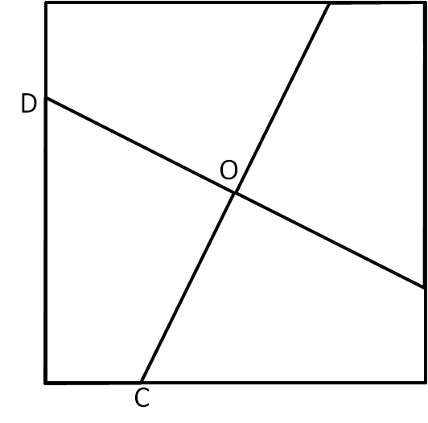
- Shaded square
Consider connecting $O$ to $X$ and $Z$, both of which are the midpoints of the sides. Then, $OX=OZ$ as $O$ is the centre of the square, and $∠OXC=90°=∠OZD$.
Then, $∠DOC=90°=∠ZOX$, so:
$∠DOZ=90°-∠ZOC=∠COX$. This makes $DOZ$ and $COX$ congruent, as they have the same angles and one pair of corresponding sides the same length.
But then, $CODY$ and $ZOXY$ have the same areas, as they both attach one of these triangles to $COZY$. This is clearly a quarter of the large square.
There are two of these unshaded areas, and both have area one quarter that of the square. This means half the square is shaded, so $12×22=2{\text{m}}^{2}$.
Alternatively, extending the lines from $D$ and $C$ past $O$ divides the square into four congruent pieces, since rotation by $90°$ takes each piece to the next. Therefore, each unshaded area is one quarter of the total area of the square.
There are two of these unshaded areas, and both have area one quarter that of the square. This means half the square is shaded, so $12×22=2{\text{m}}^{2}$.

