Stage 3 ★★★
Mixed Selection 1 – Solutions

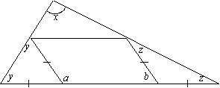
- Parallelogram in the middle
The two angles marked $y°$ are equal because they are in an isosceles triangle. For the same reason, the angles $z°$ are equal. Since an exterior angle of a triangle is the sum of the two interior and opposite angles, it follows that $a=2y$ and $b=2z$.
Now $a°+b°=180°$ since they are the base angles of a parallelogram. So $2y+2z=180$ giving $y+z=90$. But, from the angle sum of a triangle $x+y+z=180$; hence $x=90°$.

- Pentagon ring
Since each angle of a regular pentagon is $108°$, each pentagon has a turn of $36°$ to pack against its neighbour. Therefore it will take $10 (×36°)$ turns to complete a full-turn, i.e. $10$ pentagons.
Therefore $7$ more pentagons are needed.

