Stage 3 ★★★
Mixed Selection 1

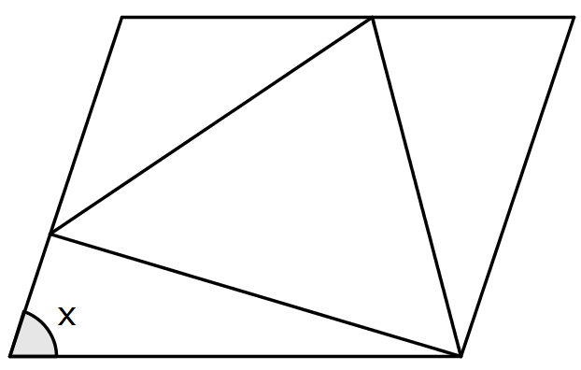
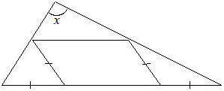
- Parallelogram in the middle
The diagram, which is not drawn accurately, shows a parallelogram inside a triangle. The marked lengths are equal.
What is the value of x?
- Equal lengths
The diagram shows an equilateral triangle inside a rhombus. The sides of the rhombus are equal in length to the sides of the triangle.
What is the value of $x$?

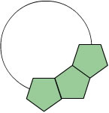
- Pentagon ring
Equal regular pentagons are placed together to form a ring as shown in the diagram which shows the first three pentagons.
How many more pentagons are needed to complete the ring?

