Stage 3 ★★
Mixed Selection 3 – Solutions

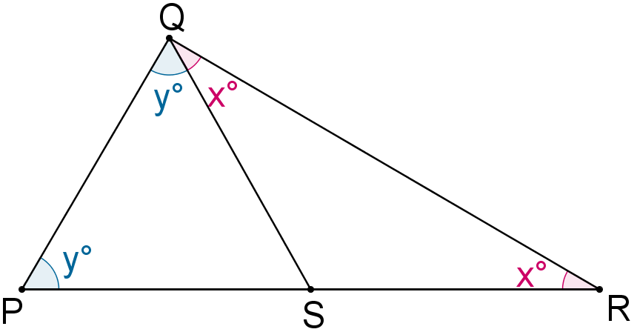
- Triangle split
Since $SP = SQ$, the triangle $PSQ$is isosceles. Therefore, $∠SPQ= ∠PQS$. We denote the measure of those angles by $y$.
Similarly, $∠SQR = ∠QRS = x°$.
Since the sum of the interior angles of $PQR$ is $180°$, $x+y+\left(x+y\right)= 180°$, so $2x+2y=180°$.
Therefore, $∠PQR=x°+y°=90°$.
- Hexapentagon
Each interior angle of a regular pentagon is $108°$, whilst each interior angle of a regular hexagon is $120°$. The non-regular pentagon in the centre of the diagram contains two angles which are interior angles of the regular hexagon, two angles which are interior angles of the regular heptagon and a fifth angle, the one marked $x$.
So: $x+2×120+2×108=5×108=540$. Hence $x=84$.
- Extended parallelogram
Opposite angles of a parallelogram are equal, so $∠QPS = 50°$. Therefore, $∠QPT = 112°$ and, as triangle $QPT$ is isosceles, $∠PQT = (180°-112°)/2=34°$.
As $PQRS$ is a parallelogram, $∠PQR = 180° - 50° = 130°$.
So, $∠TQR = 130° - 34° = 96°.$
- Six minutes past eight
At $8$ o'clock, the obtuse angle between the hands of the clock is $120°.$ In the following six minutes, the minute hand turns through an angle of $36°$ whilst the hour hand turns through an angle of $3°$ in the same direction (clockwise!). So the obtuse angle between the hands increases by $33°$, to $153°$.
- U in a pentagon
Each interior angle of a regular pentagon is $108°$, so $∠SRQ=108°$. As $SR=QR$, the triangle is isosceles with $∠RQS=∠RSQ=36°$. Similarly, $∠SRT=∠STR=36°$. So $∠SUR=(180-2×36)°=108°$. From the symmetry of the figure,
$∠PUR=∠PUS=(360°-108°)/2=126°.$

