Stage 3 ★★
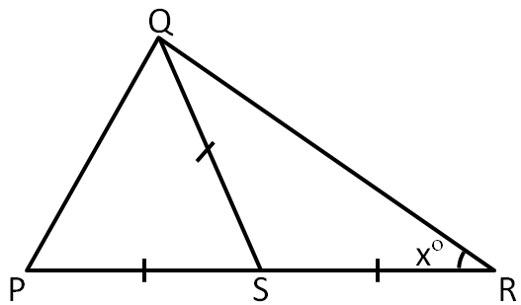
Mixed Selection 3
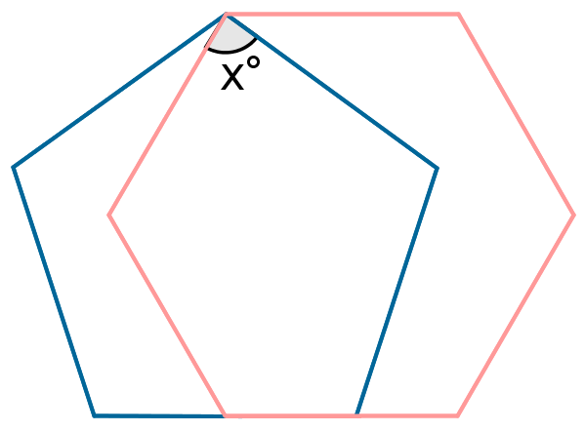
- Triangle split
In the diagram the length $SP, SQ$ and $SR$ are equal and the angle $SRQ$ is $x°$.
What is the size (in degrees) of the angle $PQR$?
- Hexapentagon
The diagram shows a regular pentagon and regular hexagon which overlap.
What is the value of $x$?
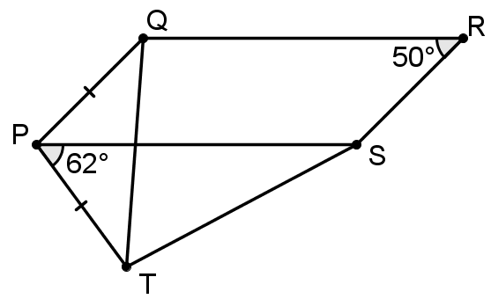
- Extended parallelogram
In the diagram, $PQRS$ is a parallelogram; $∠QRS=50°$;$∠SPT=62°$ and $PQ=PT$.
What is the size of $∠TQR$?
- Six minutes past eight
What is the obtuse angle between the hands of a clock at 6 minutes past 8 o'clock?
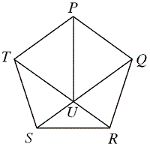
- U in a pentagon
The diagram shows a regular pentagon $PQRST$.
The lines $QS$ and $RT$ meet at $U$.
What is the size of the angle $PUR?$

