Stage 3 ★★
Mixed Selection 2 – Solutions

- Right angled octagon
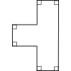
$6$ right angles can be achieved, as in the diagram below:
If there were seven right angles, these would be a total of $7×90°=630°$. The total interior angle of an octagon is $6×180°=1080°$, so the final angle would have to be $1080°-630°=450°$. The interior angle cannot be more than $360°$, so this cannot be achieved.
- Fangs
Alternate angles $BDF$ and $DFG$ are equal, so lines $BD$ and $FG$ are parallel.
Therefore, $∠BCA = ∠FGC = 80°$ (corresponding angles).
Consider triangle $ABC: x+70+80=180,$ so $x=30°$.
- Integral polygons
The greatest number of sides the polygon could have is $360$.
As each interior angle of the polygon is a whole number of degrees, the same must apply to each exterior angle. The sum of the exterior angles of a polygon is $360°$ and so the greatest number of sides will be that of $360$-sided polygon in which each interior angle is $179°$, thus making each exterior angle $1°$.
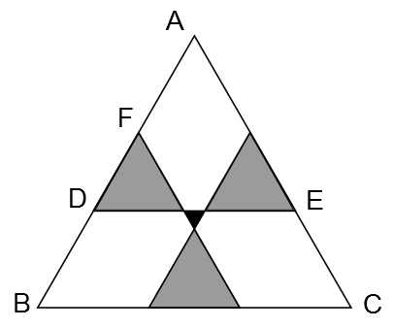
- Radioactive triangle
As triangle $ABC$is equilateral, $∠BAC = 60°$. Since the grey triangles are equilateral, $∠ADE = 60°$, so the triangle $ADE$ is equilateral.
The length of the side of this triangle is equal to the length of $DE=(5+2+5)\text{cm}=12\text{cm}$. So $AF=AD-FD=(12-5)\text{cm}=7\text{cm}$.
By a similar argument, we deduce that $BD=7\text{cm}$, so the length of the side of the triangle $ABC=(7+5+7)\text{cm}=19\text{cm}$.
- Rhombus diagonal
Adjacent angles on a straight line add up to $180°$, so
$∠GJF = 180° -111° = 69°$.
In triangle $FGJ$, $GJ = GF$ so $∠GFJ = ∠GJF$.
Therefore, $∠FGJ =(180 - 2 × 69)° = 42°$.
Since $FGHI$ is a rhombus, $FG = FI$ and hence $∠GIF = ∠FGI = 42°$.
Finally, from triangle $FJI$, $∠JFI = (180 - 111 - 42)° = 27°$.
- Inscribed hexagon
As the sum of the angles in a triangle is $180°$ and all four angles in a rectangle are $90°$, then sum of the two marked angles in the triangle $180° - 90° = 90°.$
Each interior angle of a regular hexagon is $120°$ and the sum of the angles in a quadrilateral is $360°;$ hence the sum of the two marked angles in the quadrilateral is $360° - 90° - (360° - 120°) = 30°$.
Hence the sum of the four marked angles is $90° + 30° = 120°$.

