Stage 3 ★★
Mixed Selection 2

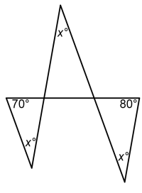
- Right angled octagon
A quadrilateral can have four right angles. What is the largest number of right angles an octagon ($8$ sides) can have?
- Fangs
What is the value of $x$ in this diagram?

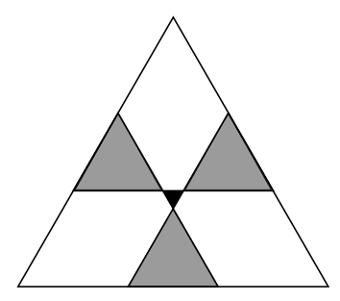
- Integral polygons
Each interior angle of a particular polygon is an obtuse angle which is a whole number of degrees.
What is the greatest number of sides the polygon could have?
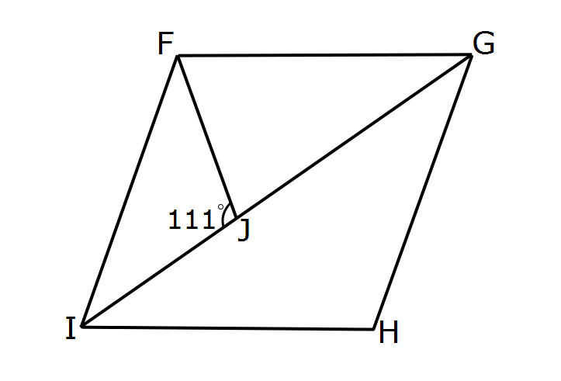
- Radioactive triangle
The diagram shows a large equilateral triangle divided by three straight lines into seven regions. The three grey regions are equilateral triangles with sides of length $5\text{cm}$ and the central black region is an equilateral triangle with sides of length $2\text{cm}$.
What is the side length of the original large triangle?
- Rhombus diagonal
The diagram on the right shows a rhombus $FGHI$ and an isosceles triangle $FGJ$ in which $GF = GJ$, and $∠FJI = 111°$.
What is the size of the angle $JFI$?
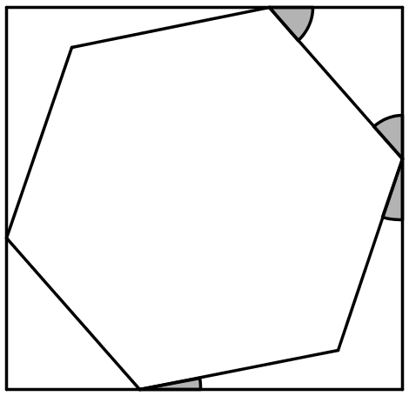
- Inscribed hexagon
The diagram shows a regular hexagon inside a rectangle.
What is the sum of the four marked angles?

