Stage 3 ★★
Mixed Selection 1 –Solutions

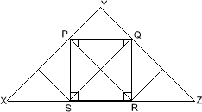
- Square in a triangle
The diagram shows that triangle $XYZ$ may be divided into $9$ congruent triangles. The square $PQRS$ is made up of $4$ of these $9$ triangles. Therefore, the area is $4:9$.

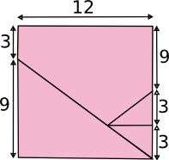
- Rectangle dissection
The square's perimeter is $12×4=48$.
You could also look at the area of the rectangle. This is $16×9=144$. This must be the same as the square, so the square must have side lengths of $12$. Therefore its perimeter is $12×4=48$.
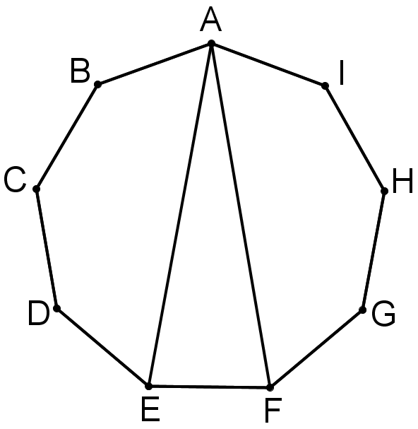
- Nonagon angle
The interior angle of a regular nine-sided polygon $=180°-\left(360°÷9\right)= 140°.$
Consider the pentagon $ABCDE$:
$$∠EAB= \frac{1}{2}\left(540°-3×140°\right)=60°$$Similarly, $∠FAI=60°$ and hence $∠FAE=140°-\left(60°+60°\right)=20°.$
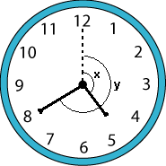
- Handy angles
Let $x$ denote the angle between the hour hand and the vertical, and $y$the angle between the minute hand and the vertical.
$\frac{360}{12}=30$ so we calculate that $x=\left(4+\frac{2}{3}\right)×30=140°$ and$y=8×30=240°$.
Hence, the angle between the hands is
$y-x=240°-140°=100°$.
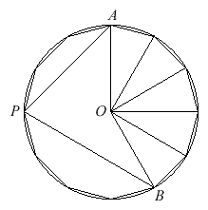
- Dodecagon angles
Each side of the dodecagon subtends an angle of $30°$ at the centre of the circumcircle of the figure (the circle which passes through all $12$ of its vertices).
Since $∠AOP=90°$, $∠OPA=45°$. Since
$∠BOP=120°$, $∠OPB=30°$. Therefore,
$∠APB=45°+30°=75°$.
Alternatively, $∠AOB=150°$ and, as the angle subtended by an arc at the centre of a circle is twice the angle subtended by that arc at a point on the circumference, $∠APB=75°$.
- Outside the boxes
At each vertex of the triangle, four angles meet which must add up to $360°$. Therefore, altogether the twelve angles add up to $3 x 360°$. Six of the angles are right-angles, and three of them are the internal angles of the triangle, which add up to $180°$.
So the sum of the remaining three angles must be
$(3 × 360°) - (6 ×90°) - 180° = 360°$.

