Stage 3 ★★
Mixed Selection 1
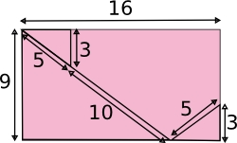
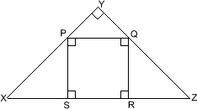
- Square in a triangle
The diagram shows a right-angled isosceles triangle $XYZ$ which circumscribes a square $PQRS$.
What is the ratio of the area of square $PQRS$ to the area of the triangle $XYZ$?
- Rectangle dissection
The 16 by 9 rectangle is cut as shown.
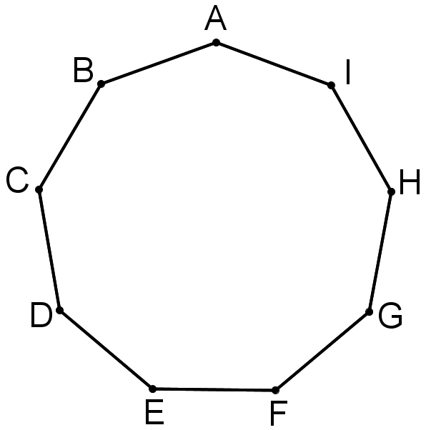
If the pieces are rearranged to form a square, what is the perimeter of the square?
- Nonagon angle
$ABCDEFGHI$ is a regular nine-sided polygon (called a 'nonagon' or 'enneagon').
What is the size of the angle $FAE$?
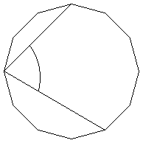
- Handy angles
How big is the angle between the hour hand and the minute hand of a clock at twenty to five?
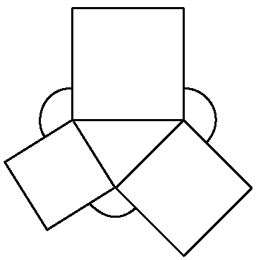
- Dodecagon angles
The diagram shows a regular dodecagon (a polygon with twelve equal sides and equal angles).
What is the size of the marked angle?
- Outside the boxes
The diagram shows three squares drawn on the sides of a triangle. What is the sum of the three marked angles?

