Stage 3
Mixed Selection 4 - Solutions
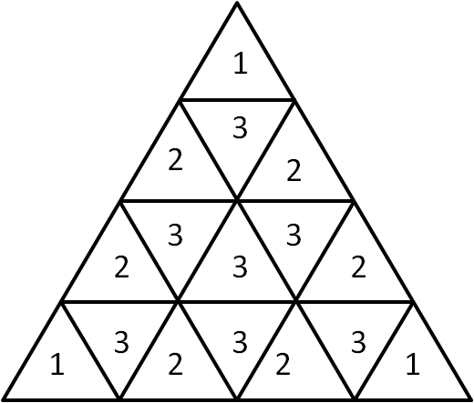
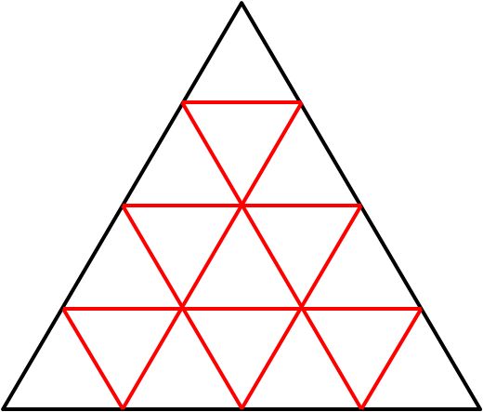
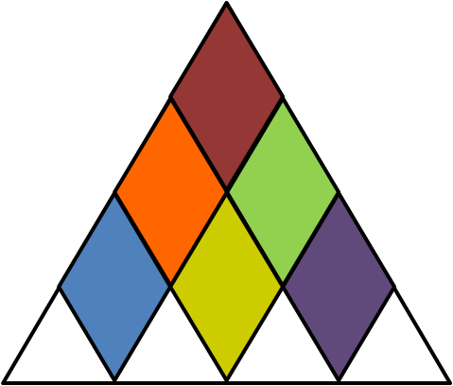
- Isometric rhombuses
There are a number of different ways of solving this problem.
Directions
The number of vertical rhombi can be seen by looking at the possible positions of the top triangle. The following six rhombi are then apparent.
The problem has rotational symmetry, so the other two directions will also give six rhombi each.
This means that the total number of rhombi is $3×6=18$.
Interior Edges
Each rhombus that is formed has exactly one of the interior edges (marked in red) contained within it. Moreover, each interior edge corresponds to one rhombus, consisting of the triangles on either side. There are $18$ interior edges, so $18$ rhombi that can be formed.
Double-counting
For each of the small triangles, the number of rhombi that contain it can be counted, as shown in the diagram on the right. However, this counts each rhombus twice (once for each triangle it contains). Therefore the total obtained ($36$) must be halved, giving a total of $18$ rhombi.
- Equilateral pair
Since $VXW$ is an equilateral triangle, $∠VXW=60°$. Therefore, $∠WXY=∠WXV+∠VXY=60°+80°=140°$.
Since the equilateral triangles are congruent, $WX=XY$, so the triangle $WXY$ is isosceles.
Hence, $∠YWX=∠XYW=\frac{1}{2}(180°-∠WXY)=\frac{1}{2}(180°-140°)=20°$.
Then, since $VXW$ is equilateral,$∠VWX=60°$.
Then, $∠VWY=∠VWX-∠YWX=60°-20°=40°$.
- Overlapping beer mats
The top beer mat, outlined in red in the diagram below, can be split into triangles from its centre, as shown below.
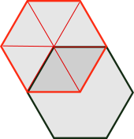
Because the hexagon is regular, the triangles are all the same, so each one will have area $6 cm^{2}$ (since the area of the whole beer mat is $36=6×6 cm^{2}$).
So, since the overlap consists of 2 of the triangles, its area is $12 cm^{2}$.
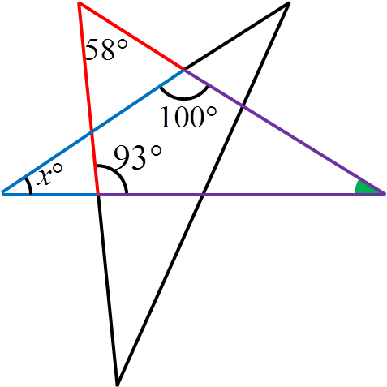
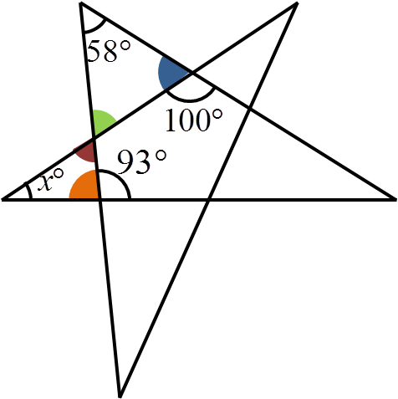
- Angles please
There are two different ways of calculating the angle x.
The first method is as follows:
The blue angle can be calculated since angles on a straight line add to $180°$. This means it is $180°-100°=80°$.
The orange angle can be calculated similarly, to be $180°-93°=87°$.
The green angle can then be calculated since the angles in the top-left triangle add up to $180°$. This is $180°-80°-58°=42°$.
The green and red angles are opposite angles. This means that they are equal, so the red angle is also $42°$.
Then, the angles in the left-hand triangle must add up to $180°$, so $x°=180°-42°-87°=51°$.
The other method is by considering the farthest right angle as shown in the diagram.
The angles in the red and purple triangle must add up to $180°$, so the green angle is $180°-58°-93°=29°$.
Then, the angles in the blue triangle must also add up to $180°$.
Therefore, $x°=180°-29°-100°=51°$.

