Stage 3
Mixed Selection 4
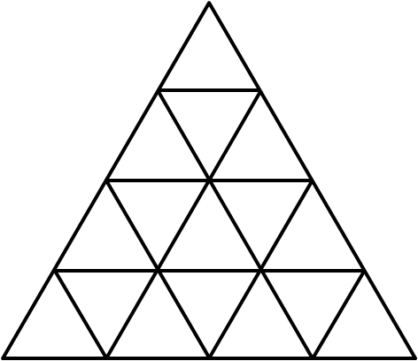
- Isometric rhombuses
The diagram shows a grid of $16$ identical equilateral triangles.
How many rhombuses made up of two adjacent small triangles are there?
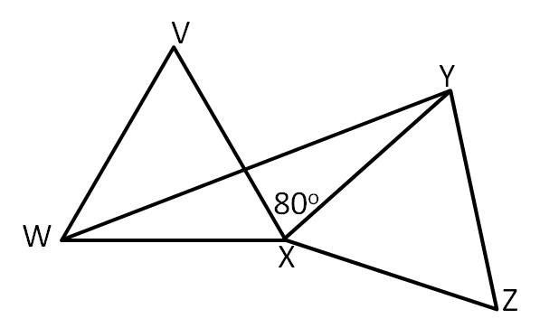
- Equilateral pair
In the diagram, $VWX$ and $XYZ$ are congruent equilateral triangles, and +∠VXY is $80°$.
What is the size of $∠VWY$?
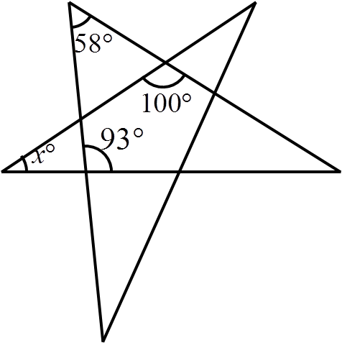
- Overlapping beer mats
Two beer mats, each the shape of a regular hexagon with area $36cm^{2}$, are placed on top of each other, as shown .
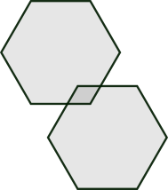
If they are placed so that the corner of the lower beer mat is in the centre of the higher beer mat, as shown below, what is the area of the overlap?
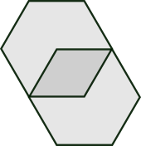
- Angle please
In the diagram, what is the value of $x$?

