Stage 3 ★
Mixed Selection 3 – Solutions

- Parallel base
Since $ST$ is parallel to $UV$, $∠PRT$ and the angle of size $132°$are corresponding angles, so $∠PRT=132°$.
Since angles on a straight line sum to $180°$ we must have
$∠PRQ=48°$.
By the exterior angle of a triangle theorem, $∠SQP=∠QPR+∠PRQ$,
so $134=x+48$, that is, $x=86$.
- Other side
The angles in triangle $ACD$ must add up to $180°$, so
$∠CDA=180°-65°-50°=65°$.
This means that $∠ACD=∠CDA$, so $ACD$ is an isosceles triangle. Therefore, $AC=AD$.
We know from the question that, $AD=BC$, so $BC=AC$. This makes $ABC$ an isosceles triangle, and $∠CAB=∠ABC$.
Then $∠ABC=12(180°-∠ACB)=12(180°-70°)=55°$.

- Half past two
In moving from one number on the clock face to the next, a hand moves $360° ÷12°=30°$.
At $2:30$ the hour hand will be exactly half way between the $2$ and the $3$, and the minute hand will be exactly on the $6$. So the angle between the two hands will be $3×30°+15°=105°$
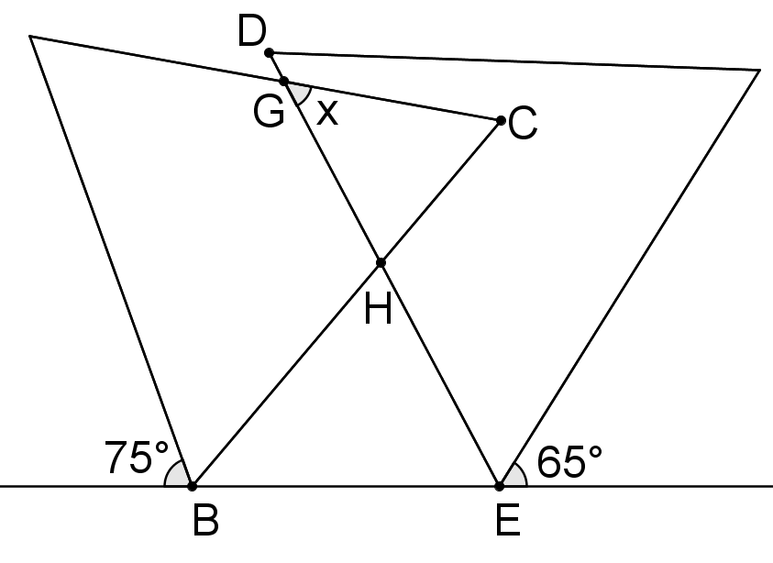
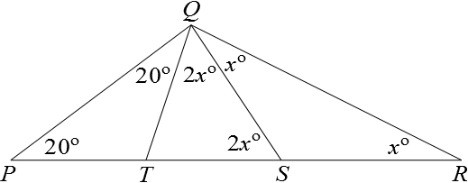
- Tent poles
As QS=SR, triangle SQR is isosceles, so $∠SRQ=∠SQR=x°$. So by the exterior angle theorem $∠QST=2x°$.
Also, $∠ TQS=2x$ since $QT=TS$.As $PT=QT, ∠TPQ=∠TQP=20°$.
Since the interior angles of triangle $PQR$ must sum to $180°$, we obtain $20+(20+2x+x)+x=180$, and hence $x = 35$.
- Angle of overlap
$$∠CBE=\left(180-75-60\right)°=45° \\ ∠DEB=(180-65-60)°=55°$$$∠GHB=\left(45+55\right)°=100°$(exterior angle of a triangle)
$∠HGC=(100-60)°=40°$(exterior angle of a triangle)

