Stage 3 ★
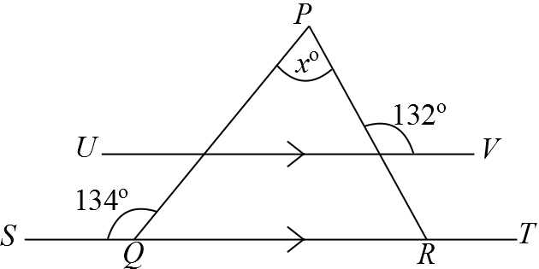
Mixed Selection 3
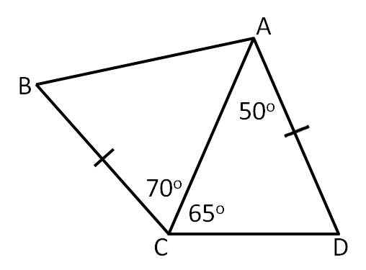
- Parallel base
In the diagram$ST$ is parallel to $UV$.
What is the value of$x$?
- Other side
The diagram shows a quadrilateral $ABCD$, in which $AD=BC$ , $∠CAD = 50°, ∠ACD = 65°$ and $∠ACB=70°$.
What is the size of $∠ABC$?
- Half past two
What is the angle between the two hands of a clock at 2:30?
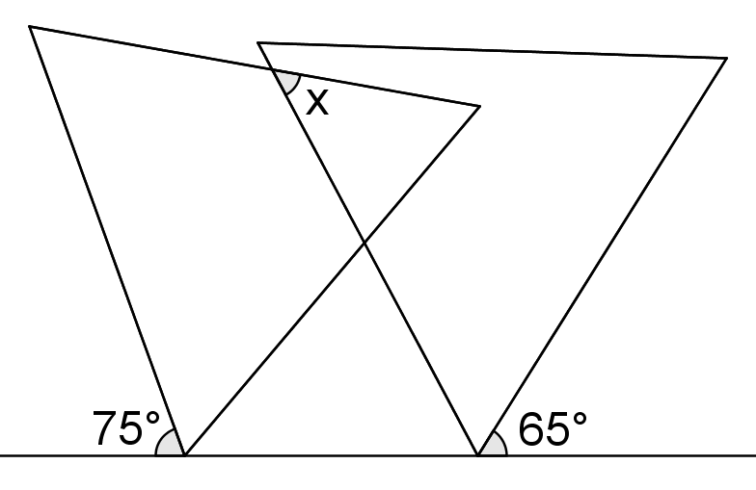
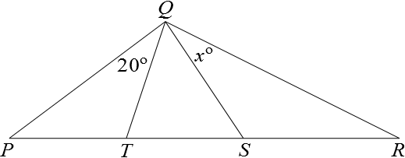
- Tent poles
In the diagram, $PT=QT=TS$, $QS=SR, ∠PQT=20°$.
What is the value of $x$?
- Angle of overlap
The diagram shows two equilateral triangles.
What is the value of $x$?

