Stage 3 ★
Mixed Selection 2

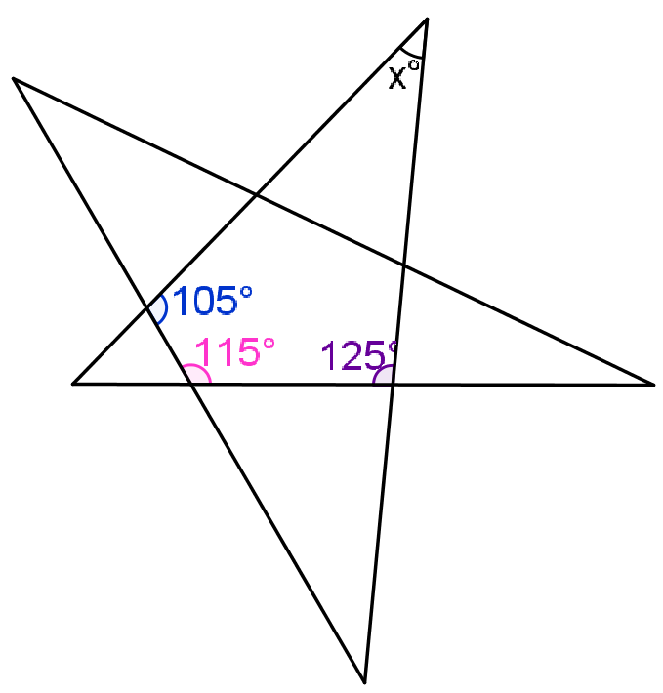
- Robo-turn
A robot, which is initially facing North, is programmed to travel $5$m then turn through $10°$ clockwise, travel $5$m then turn through $20°$ clockwise, travel $5$m then turn through $30°$ clockwise, and so on. Each move consists of moving $5$m in a straight line and then turning clockwise through an angle which increases by $10°$at each move.
How far has it travelled by the time it is first facing due East at the end of a move?
- Stellar angles
What is the value of $x$ in the diagram?
- Two exterior triangles
A square is labelled clockwise $ABCD$. $P$ and $Q$ are points outside the square such that triangles $ABP$ and $BCQ$ are both equilateral. How big is angle $PQB$?
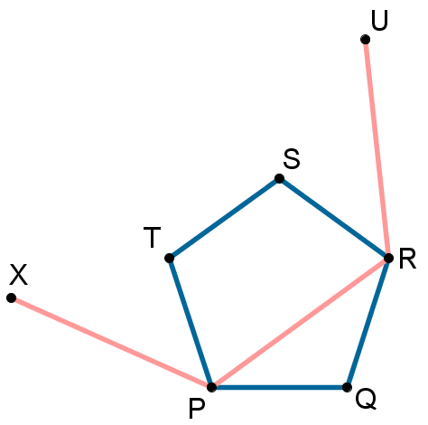
- As long as possible
The length of each side of a quadrilateral $ABCD$ is a whole number of centimetres. Given that $AB = 4 \text{cm}$, $BC = 5 \text{cm}$, and $CD = 6 \text{cm}$, what is the maximum possible length of the fourth side $DA$?
- Polygon cradle
The figure shows a regular pentagon $PQRST$ together with three sides $XP, PR, RU$ of a regular hexagon with vertices $PRUVWX$. What is the size of the angle $SRU$?

