Stage 3 ★
Mixed Selection 1 – Solutions

- Right-angled request
Four right-angled triangles can be drawn in each of the squares, plus four formed from two adjacent sides of the rectangle - that makes $12$.
Then there are two right-angled triangles formed by joining the points $UQS$ and $PTR.$
This makes a total of $14$ triangles.
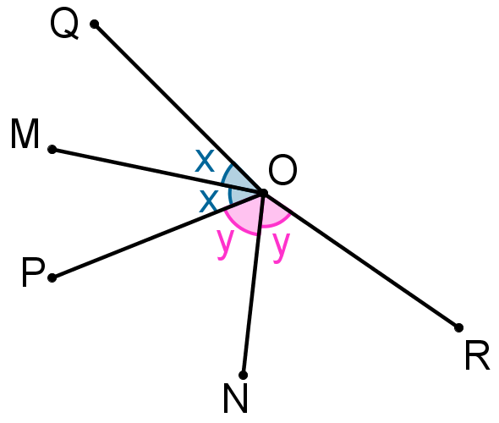
- Angular reflection
As $OQ$is the reflection of $OP$ in $OM$, $∠QOM=∠POM.$
Similarly, $∠RON= ∠PON.$
Hence, reflex $∠QOR=2×∠MON=260°.$
Therefore, $∠QOR=360°-260°=100°.$
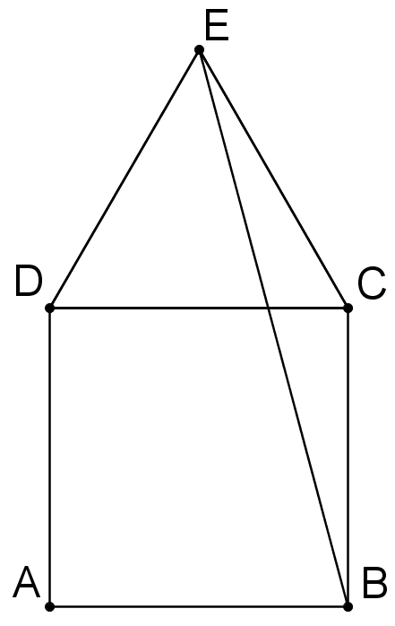
- Homely angles
Since$ABCD$is a square, $∠BCD=90°$, and since $CDE$ is an equilateral triangle, $∠DCE=60°$.
Thus $∠BCE=∠BCD+ ∠DCE=90°+60°=150°$.
Because $CDE$ is an equilateral triangle, $EC=DC$ and also, because $ABCD$ is a square, $DC=CB$. Hence, $EC=CB$ and $ECB$ is an isosceles triangle.
So $∠CEB=∠CBE= \frac{1}{2}\left(180-150\right)°=15°$, and hence $∠BED=∠CED-∠CEB=60°-15°=45°.$
- Isosceles Meld
Triangle $PQR$is isosceles. Therefore, $∠PQR= ∠PRQ=72°$.
Triangle $PSR$ is also isosceles. Therefore, $∠RPS=∠RSP=36°$.
Therefore, $x=\left(180-36-36\right)°=108°.$
- Central distance
Each centre is $2.5 \text{cm}$ from the nearer end. So the distance between them is $\left(9 - \left(2 × 2.5\right)\right)\text{cm}=4\text{cm}$.

