Stage 3 ★
Mixed Selection 1

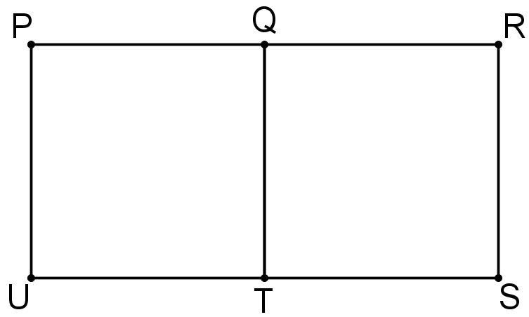
- Right-angled request
The figure shows a rectangle $PRSU$ with a line $QT$ which divides the rectangle into two squares.
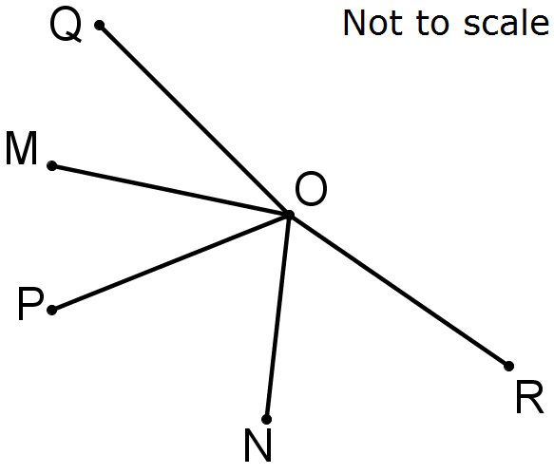
How many right-angled triangles can be drawn using any three points $P, Q, R, S, T, U$ as corners?
- Angular reflection
In the diagram, $∠MON=130°$. The reflection of $OP$ in $OM$ is $OQ$ and the reflection of $OP$ in $ON$ is $OR$.
What is the size of $∠QOR$?
- Homely angles
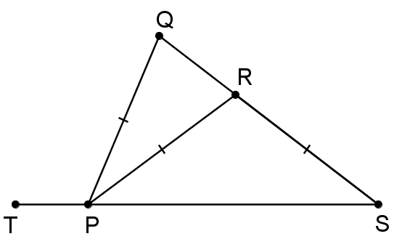
A square is labelled anticlockwise $ABCD$. The point $E$is outside the square so that $CDE$ is an equilateral triangle. Find angle $BED$.
- Isosceles Meld
In the diagram $R$ is on the line $QS$, $P$ is on the line $TS$, and $PQ = PR = RS$.
If angle $QPR$ is $36$ degrees, find the size of angle $QPT$?
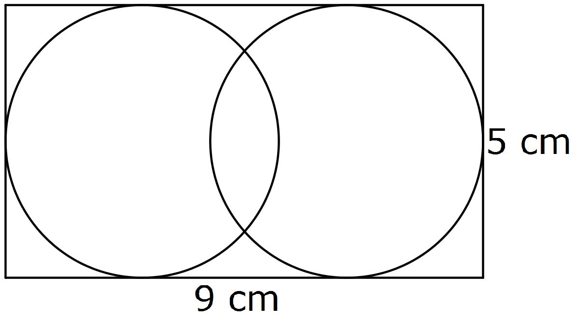
- Central distance
The diagram shows two circles enclosed in a rectangle measuring 9cm by 5cm.
What is the distance between the centres of the circles?

