Stage 3
Mixed Selection 2 – Solutions
- 12345
The number may be divided up into 400 blocks of '12345'. The sum of the digits in each block is 15 and there are 400 blocks. Hence the sum of all 2000 digits is 400 x 15 = 6000.
Alternatively, the mean of each group of five digits is 3 and so the mean of the digits making up the number is 3. Therefore the sum is 2000x3 = 6000.
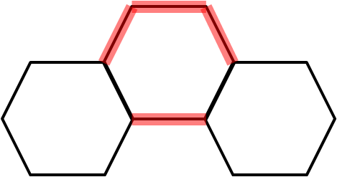
- Hexagonal line
Each of the hexagons that is not at either end of the pattern adds four sides, so 4cm, to the perimeter. This is demonstrated in the diagram on the right.
The two end hexagons contribute 5cm to the perimeter.
If there are $n$ hexagons, there are $n-2$ not at the end and 2 at the ends. Therefore the perimeter is: $4(n-2)+10=4n+2$
Then, if the perimeter is 1002cm, $4n+2=1002$. Then $4n=1000$, so $n=250$. Therefore, there are 250 hexagons in the pattern.
Alternatively, notice that each hexagon contributes 4cm to the total perimeter, except the end 2 which contribute 2 extra cm (1cm each), so if we take 2cm off the total perimeter and divide by 4 we will have the total number of hexagons in our shape. This give us $n=250$.
- Pattern snake
2004 is a multiple of 3 (since the sum is a multiple of 3) and also a multiple of 4 (since the last two digits form a multiple of 4). So 2004 is a multiple of 12 and hence the part of the pattern between 2007 and 2011 is the same as the part between 3 and 7. Answer: E
- Fibonacci deduction
If we let the fifth number be $x$, then the sixth number is $6+x=15$, so $x=9$.
The seventh number is the sum of the fifth and sixth numbers, $9+15=24$.

