Stage 3
Mixed Selection 3

- 12345
The pattern 123451234512345... is continued to form a 2000 digit number. What is the sum of all 2000 digits?

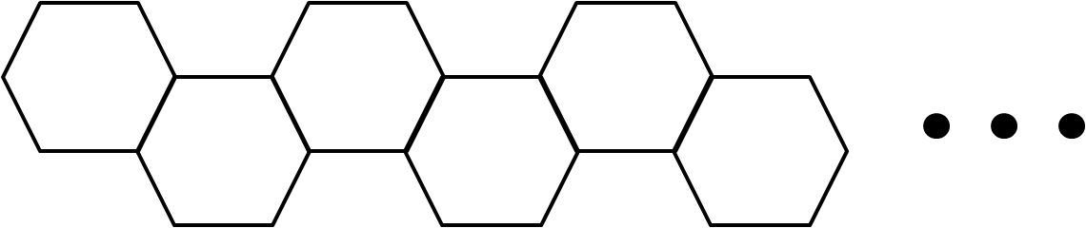
- Hexagonal line
A shape consisting of a number of regular hexagons is made by continuing to the right the pattern shown in the diagram, with each extra hexagon sharing one side with the preceding one. Each hexagon has a side length of 1cm.
How many hexagons are required for the perimeter of the whole shape to have length 1002cm?

- Pattern snake
The diagram below shows a pattern which repeats every 12 dots.
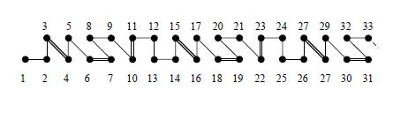
Which of the following does the piece between 2007 and 2011 look like?
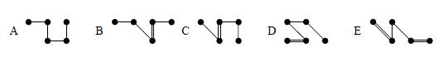
- Fibonacci deduction
Leonard writes down a sequence of numbers. After the first two numbers, each number is the sum of the previous two numbers in the sequence. The fourth number is 6 and the sixth number is 15. What is the seventh number in the sequence?

