Stage 4
Mixed Selection 3 – Solutions

- Day of the triffids
Let the number of ivy, nightshade and triffid plants be $i$, $n$ and$t$ respectively. Then:
$2i+9n+12t=120$ and $i+n+t=20$ where $i,n,t>0$.
Multiplying the second equation by 2 and subtracting the new equation from the first gives $7n+10t=80$.
Thus $7n=10(8-t)$. Therefore$n$ is a multiple of 10 and since
$1 ≤n < 20 ⇒ n=10$.
- Algebraic differences
Subtracting the second equation from the first one gives
$6x-y-(6y-x)=21-14$. So $7x-7y=7$, that is $x-y=1$.
Note that the equations may be solved to give $x=4$, $y=3$, but it is not necessary to do this in order to find the value of $x-y$.
- Table total
Adding everything together gives
Total = 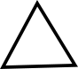 + 4 + ( + 4) + 8 +  + ( + 8) + ( + 8) + ( + 4) + 16.
Collecting like terms, Total = 3× + 3× + 52.
From the bottom row of the table (or you could use the last column), ( + 8) + ( + 4) = 16, so + + 12 = 16, so + = 4.
Then, multiplying by 3,
3×( + ) = 3 × 4, so
3× + 3× = 12.
So Total = 12 + 52 = 64.
Alternatively, we can observe a nice trick:
As shown below, the first two numbers in the bottom row add up to 16, and the first two numbers in the right hand column also add up to 16, because of the addition rules of the table.
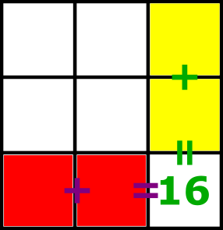
Now look at the 4 purple boxes in the diagram below. The sum of the top two numbers is equal to the number in the top right hand box, and the sum of the lower two numbers is equal to the number in the middle right hand box. So the sum of all 4 numbers is the same as the sum of the top and middle numbers in the right hand column - which is 16.
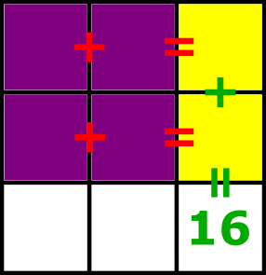
So now, as shown below, there are four areas of the table which contain numbers whose sum is 16.
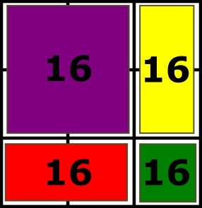 So the total is 16 + 16 + 16 + 16 = 64.
Notice that we didn't need to know anything about what was in any of the boxes except for the bottom right one.
- Square to a rectangle
Suppose the patio was a square made up of a tiles by a tiles, so there were $a^{2}$ tiles altogether. After Kevin has changed it, it is a rectangle made up of $a-3$ tiles by $a+4$ tiles, so there are $(a-3)×(a+4)$ tiles altogether. The new arrangement uses one extra tile, so $a^{2}+1=(a-3)×(a+4)$. So we have:
$$a^{2}+1=\left(a-3\right)\left(a+4\right)⇒a^{2}+1=a^{2}-a-12⇒a=13$$So Kevin had a 13 tiles by 13 tiles square, which means that he made a 10 tiles by 17 tiles rectangle.
A fuller solution is available at: http://nrich.maths.org/12813/solution

