Stage 4
Mixed Selection 3

- Day of the triffids
Jasmine spends exactly £120 on three types of plants: poisoned ivy, deadly nightshade and triffids.
Poisoned ivy plants cost £2 each, deadly nightshade plants cost £9 each and triffids cost £12 each.
She buys twenty plants in total, including at least one of each type. How many triffids did she buy?
- Algebraic differences
If $6x-y=21$ and $6y-x=14$, what is the value of $x-y$?
- Table total
In each row of the table below, the number in the third column is the sum of the numbers in the first two columns.
In each column of the table, the number in the third row is the sum of the numbers in the first two rows.
What is the sum of all of the numbers in the table?
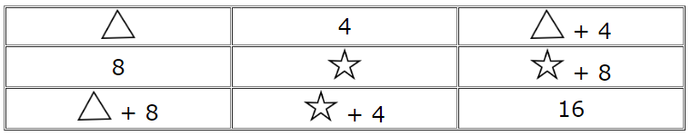
- Square to a rectangle
Kevin's patio is made up of square tiles that were arranged to make a square. He decided to change it into a rectangle by making one of the sides 3 tiles shorter, and the other side 4 tiles longer.
To make this change, Kevin only needed to buy one extra tile.
What are the lengths of the sides of the rectangle?

