Stage 4
Mixed Selection 2 – Solutions
- In the hundreds
If $\frac{1}{2}n$ is a three-digit whole number, then $n$ is an even number between 200 and 1998 inclusive.
Since we also want $2n$to be a three-digit whole number, $n$ must be an even number between 200 and 499 inclusive.
There are 150 such numbers.
- Weighing the baby
Let $m$be my weight, $b$ be the baby's weight and $n$ be the nurse's weight.
We have:
$$m+b=78 \\ b+n=69 \\ m+n=137$$Adding all three equations together we get
$\left(m+b\right)+\left(b+n\right)+\left(m+n\right)=78+69+137⇒2\left(b+m+n\right)=284 ⇒b+m+n=142.$ So the combined weight is 142kg.
- Near 10
We require that $-1<\sqrt{n}-10<1 ⇒9<\sqrt{n}<11 ⇒81<n<121$.
Hence the possible integer values for $n$ are the 39 values $n=82, 83, ... , 119, 120$.
- Weighing scales
Say a cone weighs $x$, a sphere weighs $y$ and a cube weighs $z$.
Then $\left(1\right) 2x+y=z$ since two cones and a sphere together weigh the same as a cube.
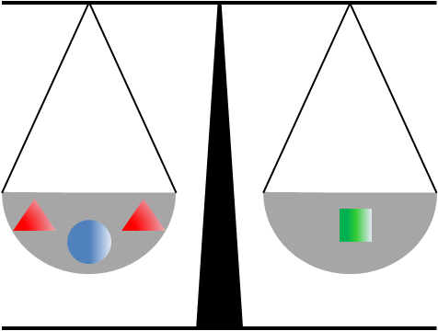
Also, $\left(2\right) y+z=3x$ since a sphere and a cube together weigh the as three cones.
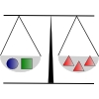
Taking y from each side of (1) (or taking a sphere from each side of the first scales) gives $\left(3\right) 2x=z-y$
Then to find out how much one cone weighs, we take equation (3) from equation (2) to give
$$3x-2x=\left(y+z\right)-\left(z-y\right) \\ ⇒x=y+z-z+y \\ ⇒x=2y$$So a cone weighs the same as two spheres.
- I love musical stars
Consider the third column:
2 +  =13 $(1)$
and the second row:
+2 =11 $(2)$
$2×(2)-(1)$ yields:
3 =9
So =3.

