Stage 4
Mixed Selection 2

- In the hundreds
For how many positive values of $n$ are both $\frac{1}{2}n$ and $2n$ three-digit whole numbers?
- Weighing the baby
Weighing the baby at the clinic was a problem. The baby would not keep still and caused the scales to wobble. So I held the baby and stood on the scales while the nurse read off 78kg. Then the nurse held the baby while I read off 69kg. Finally, I held the nurse while the baby read off 137kg. What was the combined weight of all three?
- Near 10
How many integers $n$ exist such that the difference between $\sqrt{n}$ and 10 is less than 1?
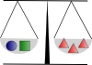
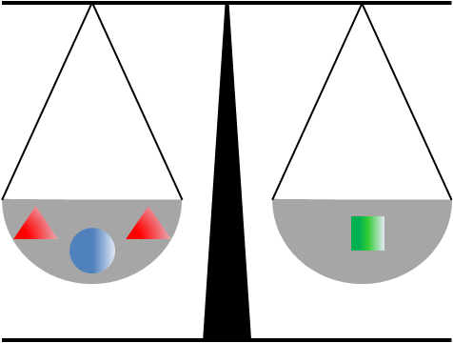
- Weighing scales
A child's box of bricks contains cubes, cones and spheres.
Two cones and a sphere on one side of a pair of scales will just balance a cube on the other side,
and a sphere and a cube together will just balance three cones.
How many spheres will just balance a single cone?
- I love musical stars
What is the value of  if each row and column has the total given?
