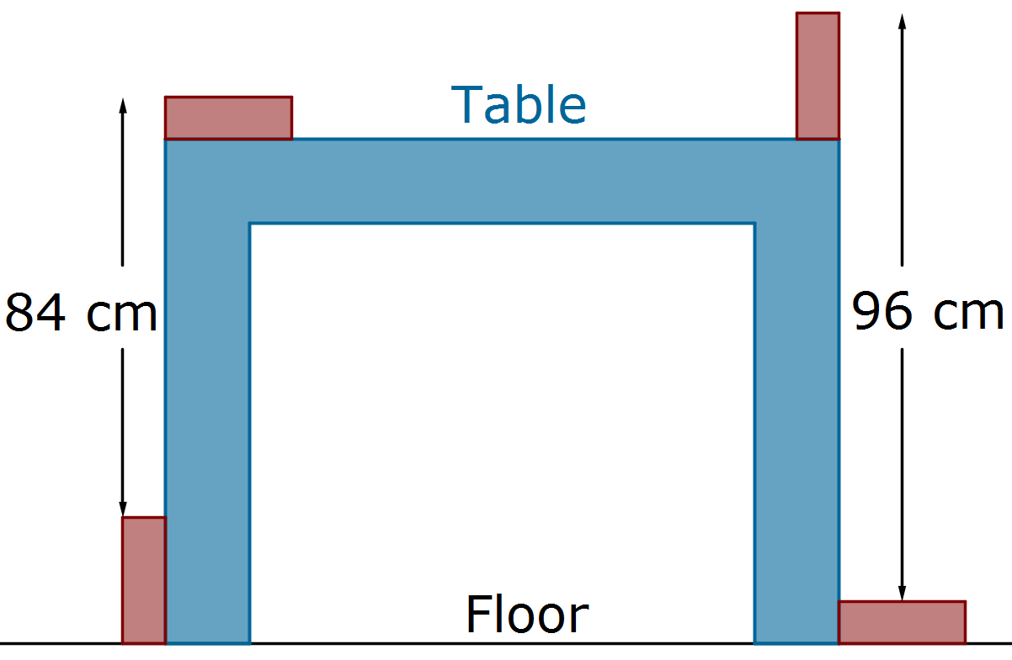
Stage 4
Mixed Selection 1
- Table height
Four identical blocks of wood are placed touching a table in the positions shown.
How high is the table?
- Adjacent additions
In a 7-digit numerical code each group of four adjacent digits adds to 16 and each group of five adjacent digits adds to 19. What is the sum of all seven digits?
- Big fish
Granny has taken up deep-sea fishing! Last week, she caught a fish so big that she had to cut it into three pieces (head, body and tail) in order to weigh it. The tail weighed 9kg and the head weighed the same as the tail plus one third of the body. The body weighed as much as the head and tail together.
How much did the whole fish weigh?
 | U | K
+ |  | 4
S | M | C
- Carry over
Each letter stands for a different digit, and S is non-zero.
Which letter has the lowest value?
- Sum = Product = Quotient
How many pairs of numbers $a$ and$b$ are there such that the sum $a+b$, the product $ab$ and the quotient $\frac{a}{b}$ of these two numbers are all equal?

