Stage 3
Mixed Selection 1 - Solutions

- How many rectangles?
Suppose there are $a$ horizontal and $b$ vertical lines. The grid of rectangles formed is then $a-1$ rectangles high, and $b-1$ rectangles wide. This means there are $(a-1)(b-1)$rectangles.
If there are a total of $15$ lines, the aim is to make $(a-1)(b-1)$ as large as possible with $a+b=15$.
This can be done by considering the different combinations that add to make $15$:
$$a$$ | $$b$$ |  | $$(a-1)(b-1)$$
$$1$$ | $$14$$ |  | $$0×13=0$$
$$2$$ | $$13$$ |  | $$1×12=12$$
$$3$$ | $$12$$ |  | $$2×11=22$$
$$4$$ | $$11$$ |  | $$3×10=30$$
$$5$$ | $$10$$ |  | $$4×9=36$$
$$6$$ | $$9$$ |  | $$5×8=40$$
$$7$$ | $$8$$ |  | $$6×7=42$$
Therefore, the largest number is $42$ rectangles, formed by having seven lines in one direction and eight in the other.
Alternatively, you can use completing the square to maximise the quantity:
Since $a+b=15$, $(a-1)(b-1)=(a-1)(14-a)=-a^{2}+15a-14$. Then, this is, completing the square, $-{\left(a-\frac{15}{2}\right)}^{2}+\frac{169}{4}$.
This is minimised when the square is minimised, which occurs when $a=7$ or $a=8$ (since a must be an integer).
This gives $6×7=42$ rectangles.
- Standing on the table
Suppose Dmitri is $d$ centimetres tall, Clement is c centimetres tall and the table is $t$ centimetres tall. The information in the question tells us that:
$$c+t=d+80 \\ d+t=c+100$$
Then, add these two equations together, which gives:
$$c+d+2t=c+d+180$$Subtracting $c+d$ from both sides gives: $2t=180$.
Dividing by $2$ gives: $t=90$.
Therefore, the table is $90\text{cm}$ tall.
- Brothers and sisters
Let $b$ represent the number of brothers in the family and s represent the number of sisters in the family.
Each brother has $b-1$ brothers, because he is one of the $b$ brothers but is not his own brother, and $s$sisters. Similarly, each sister has $b$ brothers and $s-1$sisters.
The boy has the same number of brothers as sisters, so $b-1=s$.
Each sister has half as many sisters as brothers, so the number of sisters she has is half of the number of brothers, so $s-1=\frac{1}{2}b$.
Solving by substitution or elimination, $b=4$ and $s=3$.
Solving by substitution
We want to find $b$ and $s$, where $b-1=s$ and $s-1=\frac{1}{2}b.$
$s-1=\frac{1}{2}b$, so $2s-2=b$ (by multiplying by 2).
Substituting $b=2s-2$ into $b-1=s$ gives $2s-2-1=s$, so $2s-3=s$, so $s=3$.
Substituting $s=3$ into $b-1=s$ gives $b=4$.
A fuller solution is available at http://nrich.maths.org/12771/solution
- Cuboid faces
It will be helpful to label the sides. Here, they are labelled $a, b$ and $c$.
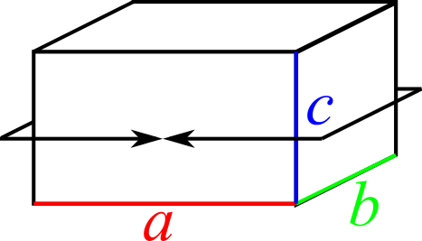
So this perimeter is equal to $a+b+a+b=2a+2b$.
Another perimeter is shown in the diagram below.
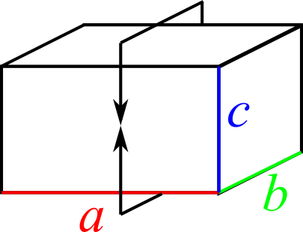
This perimeter is equal to $2a+2c$.
Similarly, the third perimeter will be equal to $2b+2c$.
So we will need to find $a, b$ and $c$ by solving the simultaneous equations
$$2a+2b=12⇒a+b=6 \\ 2a+2c=16⇒a+c=8 \\ 2b+2c=24⇒b+c=12$$Adding all 3 equations gives $2\left(a+b+c\right)=26⇒a+b+c=13$.
If $a+b=6$ and $a+b+c=13$, then $c$must be equal to the difference between 6 and 13 - which is 7.
If $a+c=8$ and $a+b+c=13$, then $b$ must be equal to the difference between 8 and 13 - which is 5.
If $b+c=12$ and $a+b+c=13$, then $a$ must be equal to the difference between 12 and 13 - which is 7.
So the volume is $1×5×7=35cm^{3}$.
A fuller solution is available at: https://nrich.maths.org/12780/solution
- Square total
Suppose Anastasia thinks of the number $a$. Then Barry doubles it to get $2a$. Connor triples this to get $6a$ and Damion multiplies it by 6 to get $36a$.
The sum of these is then $a+2a+6a+36a=45a$. This is a square number.
There are two alternative methods you can use from here.
You could work out the value of $45a$ starting at 1 until you get a square number: 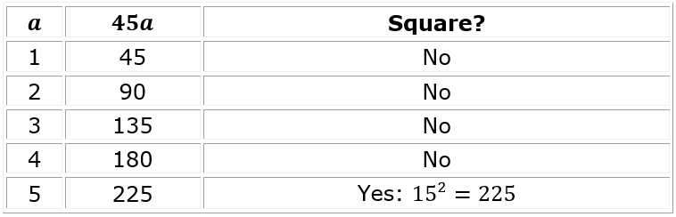
This shows that the smallest possible number would be 5.
Alternatively, for $45a$ to be a square number, each of its prime factors must be raised to an even power. Since $45=3^{2}×5$ as a product of prime factors, the only prime factor not raised to an even power is 5.
Therefore the smallest value of $a$ that makes this a square must be 5.

