Stage 3
Mixed Selection 1

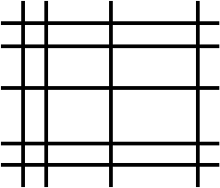
- How many rectangles?
By drawing $9$ lines, $5$ horizontal and $4$ vertical, one can form $12$ small rectangles, as shown on the right.
What is the greatest possible number of small rectangles that one can form by drawing $15$ lines, either horizontal or vertical?
- Standing on the Table
When Clement stands on a table and Dmitri stands on the floor, Clement is $80\text{cm}$ taller than Dmitri. When Dmitri stands on the table and Clement stands on the floor, Dmitri is $1\text{m}$ taller than Clement.
How tall is the table?
- Brothers and sisters
A boy has the same number of sisters as brothers.
Each of his sisters has only half as many sisters as brothers.
How many brothers and sisters are in the family altogether?
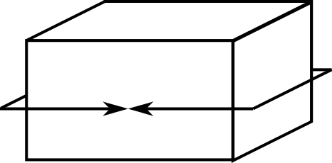
- Cuboid perimeters
The 'perimeter' of a cuboid can be measured along three axes. One 'perimeter' of this cuboid is shown.
If the perimeters of a cuboid are 12 cm, 16 cm and
24 cm, what is the volume of the cuboid?

- Square total
Anastasia thinks of a positive integer.
Barry doubles Anastasia’s number.
Connor trebles Barry’s number.
Damion multiplies Connor’s number by 6.

Eve notices that the total of the four numbers is a perfect square.
What is the smallest positive integer that Anastasia could have thought of?

