Age 11+ Level
Worksheet 1

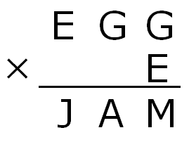
- Jam and Egg Sandwich
Each different letter in the multiplication on the right stands for a different digit.
Identical letters stand for the same digit.
Work out the value which each letter represents.

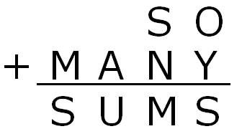
- So Many Sums
In this addition, each letter stands for a different digit, with S standing for 3.

What is the value of Y x O?

- Rolling Along the Trail
A pair of dice is thrown and the score is obtained by finding the product of the two numbers when they land.
In five throws of both dice:

the second score is 5 more that the first;
the third score is 6 less than the second;
the fourth score is 11 more than the third;
the fifth score is 8 less than the fourth.

What was the score for each of these five throws?

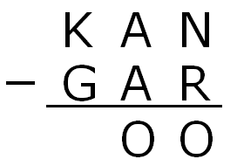
- Kangaroo Subtraction
In this subtraction, each of the letters K, A, N, G, R and O represents a different digit.
What is the largest possible value of the number 'KAN'?
- Operational Decision
Which symbol (+,-,÷ or ×) should replace ⊕ to make the following equation true?

$$1 × 2 × \left(3⊕4+5\right) × (6 × 7+8+9)=2006$$

