Age 11+ Level
Worksheet 3

- Identical Digit Multiplication
77 is multiplied by another two-digit number with identical digits.

The third digit of the product, counting from left to right, is a 3.
What is the product?
- In Sum-mary
The sum of three numbers is 2009. The sum of the first two numbers is 1004, and the sum of the last two is 1005.
What is the product of all three numbers?

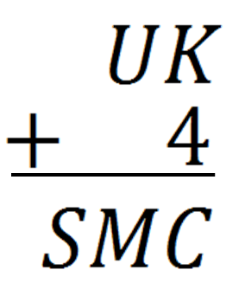
- Carry Over
Each letter stands for a different digit,
and S is non-zero.

Which letter has the lowest value?
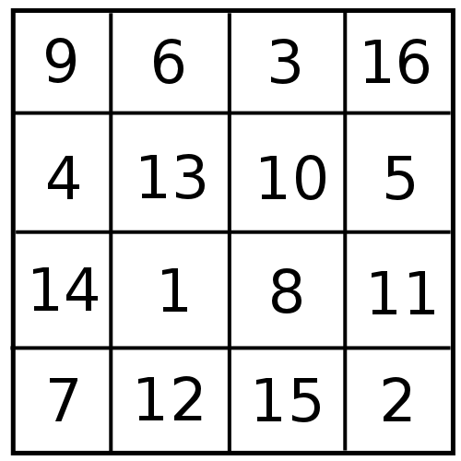
- Magic Error
Two numbers in the 4 x 4 grid can be swapped to create a Magic Square (in which all rows, all columns and both main diagonals add to the same total).
What is the sum of these two numbers?
- Walk or Run?
When John walks to school and then runs home, it takes him 40 minutes. When he runs both ways, it takes him 24 minutes.
He has one fixed speed whenever he walks, and another fixed speed whenever he runs.
How long would it take him to walk both ways?

