Age 11+ Level
Worksheet 2

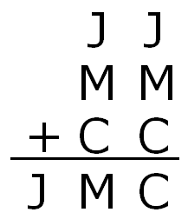
- Down and Along
The letters $J$, $M$ and $C$ represent three different non-zero digits.
What are the values of $J$, $M$ and $C$?
- 354972
What is the remainder when 354972 is divided by 7?
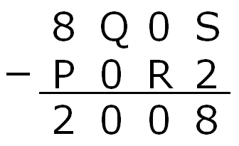
- Subtracting to 2008
In this subtraction, P, Q, R and S are digits. What is the value of P + Q + R + S?

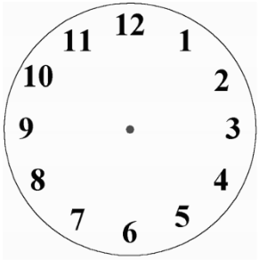
- Split Clock face
Use 2 straight lines to split the clock face into 3 parts, so that the sums of the numbers in each of the parts are equal.

- 50, 50, 50 and 50
Aroon says his age is $50$ years, $50$ months, $50$ weeks and $50$ days. What age will he be on his next birthday?

- Missing Digits
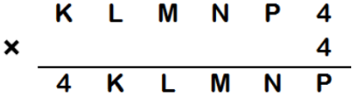
In this calculation, K, L, M, N and P each denote a single digit.

Find K, L, M, N and P.

