Age 11+ Level
Worksheet 1

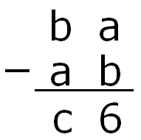
- Reverse Subtraction
In this subtraction, a, b and c are digits, and a is less than b. What is the value of c?

- Bus Route
Nine bus stops are equally spaced along a bus route.
The distance from the first to the third is 600m.
How far is it from the first to the last?

- Debasing the Coinage
In 1990 a new size 5p coin was minted. The old size weighed 5.65g while the new size weighs 3.25g.
How much lighter will your pocket be if it contains £5 worth of the new size coins instead of the old size?

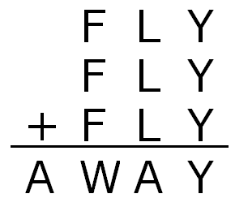
- Fly Away
In this addition, each letter represents a different non-zero digit.

Find the values of A, F, L, W and Y.

- Hot Dogs
A hot dog lover ate 60 hot dogs over an 8-day period. Every day, she ate one more hot dog than she had eaten the day before.
How many hot dogs did she eat on the first day?

- 2014 Even Numbers
What is the difference between the sum of the first 2014 odd numbers and the sum of the first 2014 even numbers?

