Age 14+ Level
Worksheet 2

- Porridge
To make porridge, Goldilocks mixes together 3 bags of oats with one bag containing 20% wheat bran and 80% oats.
All the bags have the same volume.
What percentage of the volume of Goldilocks' porridge mixture is wheat bran?

- Test Scores
Ivan, Tibor and Alex sat a test and achieved $85\%$, $90\%$ and $95\%$ respectively. Tibor scored just one more mark than Ivan.
How many marks did Alex get?

- Tennis Club
Three-quarters of the members of a junior tennis club are boys and the rest are girls.
What is the ratio of boys to girls among these members?

- Baby Boom
The populations of five cities A, B, C, D, E, in 1998 and 1988, are shown on these scales.
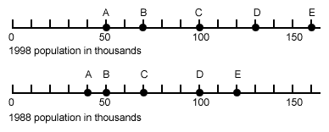
Which of the five cities showed the largest percentage increase in population from 1988 to 1998?

- Pied Piper
On Monday the Pied Piper caught 1000 rats in a city.
On Tuesday he caught 10% fewer rats than on Monday.
On Wednesday he caught 20% more than on Tuesday.
On Thursday he caught 30% fewer than on Wednesday.
On Friday he rested.
How many rats did he catch in total that week?

