Age 14+ Level
Worksheet 1

- A Drink of Water
A bottle contains 750ml of mineral water. Rachel drinks 50% more than Ross, and the two friends finish the bottle between them.
How much does Rachel drink?
- Entrance Exam
In a university admissions test, Dean gets exactly 10 of the first 15 questions correct. He then answers all the remaining questions correctly.
Dean finds out he has answered 80% of all the questions correctly.
How many questions are there on the test?

- Petrol Station
Andrea's petrol tank holds up to 44 litres of fuel.
She goes to the garage when her tank is a quarter full and fills up the tank until it is two-thirds full.
How many litres of petrol does she put in the tank?

- The Grand Old Duke of York
The Grand Old Duke of York had $10 000$ men.
He lost $10\%$ of them on the way to the top of the hill.
He then lost $15\%$ of the rest on the way back down.

What percentage of his $10 000$ men remained when he got to the bottom of the hill?
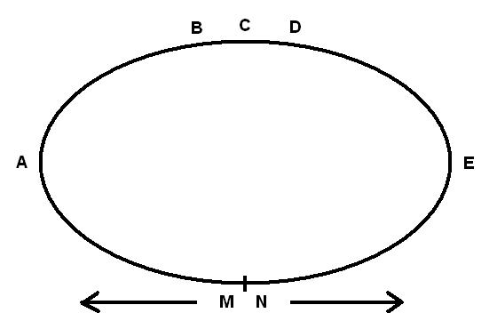
- Meeting Point
Nikki covers any distance in one third of the time it takes Malcolm to run the same distance. They set off in opposite directions around the track as shown.
Where will they meet for the first time?

