Age 11+ Level
Worksheet 1

- Too Close to Call
Arrange these fractions in order, from smallest to largest:

$$\frac{111110}{111111} \frac{222221}{222223} \frac{333331}{333334}$$

- Tricky Fractions
Find $x$, where

$$\frac{1}{2}-\frac{1}{4}+\frac{1}{8}-\frac{1}{16}+⋯-\frac{1}{1024}=\frac{x}{1024}$$

- Peanut Harvest
My four pet monkeys and I harvested a large pile of peanuts.
Monkey A woke in the night and ate half of them;
then Monkey B woke and ate one third of what remained;
then Monkey C woke and ate one quarter of the rest;
finally Monkey D ate one fifth of the much diminished remaining pile.
What fraction of the original harvest was left in the morning?

- Slightly Outnumbered
In Miss Quaffley's class, the girls make up more than 45% of the pupils, but less than 50%.
What is the smallest possible number of girls in her class?

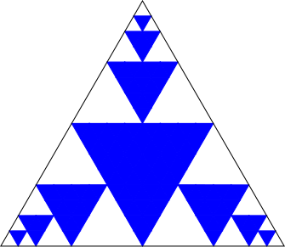
- How Shady?
The diagram below shows an equilateral triangle with some triangles shaded inside it. Each shaded triangle is equilateral and touches the sides of the largest triangle and of the shaded triangles next to it.

What fraction of the largest triangle is shaded?

