Age 11+ Level
Worksheet 2

- Between a Sixth and a Twelfth
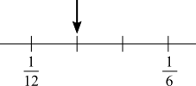
On this number line, the space between $\frac{1}{6}$ and $\frac{1}{12}$ is split into 3 equal parts.
What number is indicated by the arrow?

- Second Half Score
In the first half of their match against Range Hill School, Boarwarts Academy scored all of the points.
In the second half, each side scored three points.
At the end of the match, Boarwarts Academy had scored 90% of the points.
What fraction of the points were scored in the second half?

