Age 11+ Level
Worksheet 1

- Farthest Fraction
Which is the largest of these fractions?
a) $\frac{7}{15}$ b) $\frac{4}{9}$ c) $\frac{5}{11}$

- Smashing Time
Yesterday, Granny had 12 cups and 10 matching saucers, but this morning she dropped a tray holding one third of the cups and half the saucers, breaking all of those on the tray.
How many of her cups are now without saucers?

- Better Spelling
In Emily's first spelling test, she scored 1 mark out of 5, so she decided to work really hard to improve her scores.
If she scores full marks (5 out of 5) in all her tests after the first, how many more tests does she need to take in order to increase her average to more than 80%?

- Bouncing Ball
A ball is dropped from a height of 125 cm. Each time it hits the ground, it bounces to $\frac{3}{5}$ of the height from which it fell.

How high does it bounce after hitting the ground the third time?

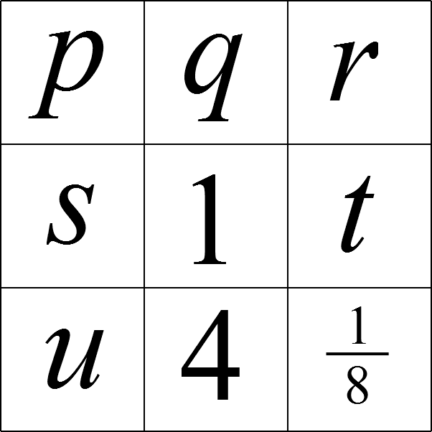
- Multiplication Magic Square
In this Multiplication Magic Square, the product of the three numbers in each row, column and diagonal is 1.

What is the value of $r+s$?

- Percentage Mad
What is 20% of 30% of 40% of £50?

